in-class: project brainstorm and grounding

In-class Group Worksheet: Project Topic Brainstorm & Grounding
Course: IST 402 – Health Informatics & AI
Group 6: Grace Liou, Zack Ranjan, Simone Orange

Part 1: Pick a health/wellness topic (be specific)
Initial topic idea: AI for mental health, specifically use cases and results with popular LLMs (Gemini, ChatGPT, etc.) compared against mental health specific AIs (Headspace, Ash, etc.) – creating/adding a feature to an existing popular LLM that allows people to share specific concerns and get more targeted responses.

Refined idea:
- Condition or focus: Researching existing use cases for mental health support provided by popular language learning models (LLMs), such as Gemini and ChatGPT, and comparing them to current mental-health specific AIs, such as Headspace or Ash, to find similarities, gaps, and ethical considerations. The goal is to create a feature for LLMs that would allow users to ask specific questions about their mental health and get more targeted responses.
- Target population: Young adults (18-35 years old) who use general-purpose LLMs for various tasks that would benefit from dedicated mental health conversation capabilities.
- Context of use: Users turn to AI chatbots for support during moments of stress, anxiety, loneliness, or emotional difficulty but find generic LLM responses lack the specialized empathy, therapeutic frameworks, and safety guardrails of mental health-specific AI tools.

Part 2: Identify the design problem and users
Primary users:
- Age range: 18-35
- Role: Uses an LLM to be able to ask any questions or for help with their mental health. The user will be able to directly speak with the chatbot and have a conversation to ease any concerns.
- Relevant characteristics: In a stage of constant change in their lives, want to practice emotional awareness and regulation, experiencing intense identity exploration, conscious/familiar with AI’s lack of autonomy when prompting

Design problem statement: Our user struggles with mental health because they do not have access to the resources that they need.

Part 3: Narrowing the focus
Target users: Young adults (ages 18-35) who regularly use general-purpose LLMs for productivity, learning or creative tasks, and occasionally turn to these tools for emotional support or mental health conversations. They may often access AI tools late at night or during acute stress when traditional support isn’t available or accessible to them (financial burdens), want privacy, anonymity, and immediate, quality, evidence-based responses when discussing mental health concerns. These users value the convenience and accessibility of AI but feel current platforms provide inadequate responses for mental health concerns.

Specific problem statement: Young adults struggle with regulating their mental health when there’s a lot going on in their lives, because they’re in a stage of life that comes with many milestones, which is due to the many changes that occur during this time (shifting from childhood to adulthood).

Part 4: Design lens/health informatics model
Selected lens(es) that you think may be relevant: Celebratory technology, behavior change, technology appropriation

Why this lens makes sense:
Celebratory Technology: This lens is relevant because mental health support should focus on strengths, resilience, and positive emotional experiences rather than purely deficit-based approaches. A celebratory design would acknowledge user’s coping efforts and emotional growth, celebrate small wins in managing mental health and reframe challenges as opportunities for self-discovery. It would also create positive, affirming interactions that build self-efficacy and move beyond pathologizing language to empowering conversations.
Behavior Change: This lens supports the goal of helping users develop healthier coping mechanisms and mental health practices. This would guide users toward evidence-based self-care strategies and encourage positive behavioral patterns like sleep hygiene, stress management, and social connection. They would use motivational interviewing techniques to support change and track progress in managing stress or anxiety over time. The feature could provide personalized recommendations based on user patterns.
Technology appropriation: This lens dives deeper into how users have appropriated popular LLMs as therapists, even though most AI companies warn against it. Our proposed feature validates this behavior – rather than trying to change user behavior (behavior change), the solution paves the desired path users have already walked, making it safer and more effective. It addresses the gap between intended use (information retrieval) and actual use (emotional support)

Part 5: Quick research – existing tech and relevant articles
Existing technologies: List at least 3 technologies or designs relevant to your focus.
- Search online to experiment with the design if you can. Look for design inspirations for your own project or anything you notice is problematic (explain a strong need for a redesign, or a general usability problem to address)
- For each technology, include the name, link, strengths, and limitations

- Popular LLMs
  - Name: ChatGPT
    - Link: https://chatgpt.com/
    - Strengths: Offers 24/7, accessible mental health support; provides actionable advice, coping techniques, and cognitive behavioral therapy exercises.
    - Limitations: Lack of crisis intervention, validation of harmful beliefs, can provide dangerous/harmful advice when prompted, lack of human empathy and nuance, hallucinations (generating plausible-sounding but completely inaccurate information), no data privacy
  - Name: Gemini
    - Link: https://google.gemini.com/
    - Strengths: Offers 24/7, accessible mental health support and psychoeducation, personalized wellbeing tools, lifestyle monitoring and motivation, personalized mindfulness exercises, sleep and hygiene recommendations, evidence-based informational resources; can act as a companion for journaling/mood tracking
    - Limitations: Failure to recognize crises, safety degradation in long conversations, sycophancy and lack of true empathy, distraction and loss of context, easy to overrule safety protocols, data privacy concerns
- Mental health-specific AIs
  - Name: Headspace
    - Link: https://www.headspace.com/
    - Strengths: Range of services for all needs, helps people learn coping strategies, available on phones so easily accessible, has subscriptions and family plans, designed for beginners, has the ability to connect with friends and family
    - Limitations: Can come off as repetitive, designed for beginners, only really designed for meditation and sleep
  - Name: Ash
    - Link: https://www.talktoash.com/
    - Strengths: Able to hold a conversation without sounding robotic, designed by mental health experts, available on phones, trained on clinical, expert, and user behavioral data, provides long-term support, supports data privacy and security, can identify patterns in conversations and remember past interactions, helps guide the user to determine what to work on next
    - Limitations: Lack of clinical validation (currently rudimentary) and crisis intervention capabilities, improper deescalation techniques, regulatory hurdles, tendency for unhealthy engagement, limited contextual understanding

Relevant papers/articles:
- Popular LLMs
  - Large Language Models in Mental Health: Opportunities and Challenges https://arxiv.org/abs/2401.02984
- Popular Mental health-specific AIs
  - The Real-World Impact of App-Based Mindfulness on Headspace Members With Moderate and Severe Perceived Stress: Observational Study https://pmc.ncbi.nlm.nih.gov/articles/PMC10986332/
  - Headspace Review: How Does It Stack Up? https://www.healthline.com/health/mental-health/headspace-review#cost
  - Are A.I. Therapy Chatbots Safe to Use? (Ash) https://www.nytimes.com/2025/11/06/technology/ai-therapy-chatbots-ash.html
  - Co-developing a Mental Health and Wellbeing Chatbot With and for Young People (Ash) https://pmc.ncbi.nlm.nih.gov/articles/PMC7882508/
- Other
  - Chatbots Are Not Medical Devices https://reason.com/2025/12/03/chatbots-are-not-medical-devices/

Part 6: What this informs about your design
One key insight: The most effective mental health AI solutions balance conversational naturalness and empathy (strength of general LLMs) with evidence-based therapeutic frameworks and safety protocols (strength of specialized mental health apps). Users don’t want to choose between the flexibility of ChatGPT and the therapeutic grounding of Headspace, they need both. This suggests a design approach that enhances existing LLMs with a specialized "mental health mode" that activates structured support, crisis detection, and CBT/DBT techniques while maintaining the natural conversational flow users already trust.

One thing to avoid or redesign: Avoid the subscription/paywall app barrier that limits accessibility of current mental health AI tools. Young adults use and trust general-purpose LLMs daily and requiring them to download another app, create new accounts, or pay subscriptions creates unnecessary friction. Additionally, avoiding purely scripted or rigid conversation trees that make users feel like they’re talking to a limited bot rather than receiving genuine support. The design should feel like an enhanced capability of their existing AI tool.

Early design direction: The design is a contextual “Mental Health Support” mode within existing LLMs (like a specialized feature or toggle) that activates automatically or by user choice when mental health topics are detected or requested. It would maintain conversational naturalness while incorporating evidence-based techniques like CBT and motivational interviewing. It would include robust safety features like crisis detection, resource provision, and clear boundaries about AI limitations. It would offer optional continuity like remembering themes/progress across conversations (with user consent) for personalized support, and celebrate progress to acknowledge user resilience and growth. It would also provide psychoeducation like explaining what the AI is doing therapeutically and seamlessly integrate into existing workflows.

Part 7: Feedback and revision notes:
Feedback received: Good start!

Planned revisions: Diving deeper into the topics discussed above.

📔 project lit review + market analysis

Project Literature Review & Market Analysis:

Popular LLMs vs. Mental Health specific AI tools

Group 6: Grace Liou, Zack Ranjan, Amanda Keller, Simone Orange, Oluwadamilola Ogundele

IST 402: Health Informatics & AI

February 8, 2025

Topic: Analysis on how young adults (18-35) currently use popular LLMs (ChatGPT, Gemini) for mental health support compared to specialized mental health AI tools (Headspace, Ash) in order to identify feature gaps and ethical considerations that will inform the development of dedicated mental health support capabilities within popular LLMs.

Problem Statement
In today’s digital age, young adults are increasingly turning to popular, general-purpose LLMs for mental health support during moments of acute stress, anxiety, or general emotional difficulty, especially when traditional resources are inaccessible due to financial barriers or time constraints. However, these widely-used platforms lack the specialized therapeutic frameworks, safety guardrails, and empathetic design of dedicated mental health AI tools like Headspace or Calm, leading to inadequate support, harmful advice, or missed crisis interventions. The challenge is to bridge this divide by creating a mental health support feature within these popular LLMs that combines the accessibility and conversational tone users already trust with the evidence-based therapeutic approaches and safety protocols that mental health-specific AI tools provide, without introducing barriers like paywalls or requiring users to adopt entirely new platforms.

Literature Review
In "Use of Generative AI for Mental Health Advice Among US Adolescents and Young Adults" by Ryan K. McBain and colleagues, a cross-sectional survey revealed that usage of popular LLMs were at 22.2% among those aged 18-21, aligning closely with the 18-35 demographic. The methods involved survey-weighted percentages to examine demographic associations, showing that 65.5% of users engaged monthly or more frequently and 92.7% found the advice helpful. Key insights include generative AI's appeal as a low-cost, immediate alternative amid barriers to traditional care, but design implications emphasize the need for standardized evaluation benchmarks and transparent training data to ensure advice quality, as current LLMs lack these compared to specialized apps.
In "Large Language Models as Mental Health Resources: Patterns of Use in the United States" by Tony Rousmaniere and co-authors, a survey of 499 US adults aged 18-80 with ongoing mental health conditions demonstrated that 48.7% used LLMs for psychological support in the past year, primarily for anxiety, personal advice, and depression. Key insights point to LLMs' accessibility and efficacy as supplemental tools, but design implications call for clinical guidelines to mitigate risks, as ad-hoc interactions fall short of evidence-based structures in dedicated apps.
In “This is Human Intelligence Debugging Artificial Intelligence: Examining How People Prompt GPT in Seeking Mental Health Support" by Zhuoyang Li and colleagues, a qualitative analysis of 49 Reddit threads comprising 7,538 comments explored users' strategies for eliciting mental health advice from GPT, despite its disclaimers against substituting professional care. Key insights shared that users' efforts to enhance efficiency and depth in interactions for emotional relief. Design implications advocate for safer LLM architectures that empower users while maintaining boundaries, addressing tensions between accessibility and reliability.

Market Analysis
Headspace offers guided meditation sessions designed to help users practice mindfulness and build relaxation habits. Strengths include structured content variety, progress tracking, and child-friendly features with daily notifications. However, the subscription paywall excludes users facing financial barriers, while the interface's complexity creates navigation challenges (Forbes Health, 2023). The free trial provides only limited content, preventing users from fully evaluating the platform before committing.
Calm provides sleep stories, guided meditation, soundscapes, and podcasts targeting users managing stress, anxiety, and sleep difficulties. Its user-friendly design, mood tracking, and family-friendly options appeal to meditation beginners (Healthline, 2021). Yet it shares Headspace's critical flaw: requiring paid subscriptions for full access while offering minimal free content. Additional weaknesses include difficult cancellation processes and inconsistent service quality (Tee-Melegrito, 2021).
Elomia represents clinician-designed AI chatbots offering anonymous, 24/7 mental health conversations tailored for individuals, employers, universities, and healthcare providers. Its crisis alert system for clinicians and evidence-based approach demonstrate sophisticated therapeutic infrastructure. However, as a standalone platform, it requires users to adopt an entirely new tool rather than integrating with familiar interfaces.
These platforms reveal three critical unmet needs: (1) accessibility barriers through paywalls that contradict mental health support's democratization goals, (2) fragmented user experiences requiring platform-switching away from already-trusted LLMs, and (3) standalone business models vulnerable to regulatory uncertainty. Our project addresses these gaps by integrating therapeutic frameworks directly into popular LLMs, eliminating cost barriers and adoption friction while avoiding sustainability challenges.

Synthesis & Design Space
While nearly half of young adults already use general-purpose LLMs for mental health support, yet these tools lack the clinical infrastructure of specialized apps. The literature reveals users "debugging" LLMs through creative prompting to extract empathy these platforms weren't designed to provide. Conversely, the market shows specialized tools offer evidence-based frameworks and crisis detection but erect barriers through paywalls and platform-switching requirements. Our design space lies in developing an integrated mental health feature within existing LLMs that bridges this gap. Rather than creating another vulnerable standalone app, we propose:
- Contextual filters – Simulate an intelligent detection system that recognizes when conversations shift toward mental health topics and offers users to activate a “mental health support mode.”
- Tiered response architecture – Integrating a three tier response system: (1) empathic listening with validation for general stress/venting, (2) structured therapeutic exercises like breathing techniques or cognitive reframing, and (3) immediate crisis resource intervention with warm handoffs to human services for severe concerns
- Therapeutic skills library – Provide pre-designed prompt templates for common needs, like “Help me process a difficult emotion,” or “Guide me through anxiety relief,” paired with an accessible library of micro-interventions pulled from validated approaches that users can trigger manually or automatically.

References
Balan, R., & Gumpel, T. P. (2025, December 24). CHATGPT clinical use in mental health care: Scoping review of empirical evidence. JMIR mental health. https://pmc.ncbi.nlm.nih.gov/articles/PMC12735656/#s4

Elomia chatbot: The effectiveness of artificial intelligence in the. (n.d.-a). https://ceur-ws.org/Vol-2870/paper89.pdf

Food and Drug Administration. (2025, November 6). Generative Artificial IntelligenceEnabled Digital Mental Health Medical Devices . EXECUTIVE SUMMARY FOR THE DIGITAL HEATH ADVISORY COMMITTEE MEETING. https://www.fda.gov/media/189391/download

Forbes Health. “I Tried The Headspace App—Here’s My Review.” June 14, 2023. https://www.forbes.com/health/mind/headspace-review/.

Healthline. “2024 Calm Review: We Tested the Popular Meditation App.” February 17, 2021. https://www.healthline.com/health/mental-health/calm-app-reviews.

Healthline. “Is Headspace Right For You? Here’s What Our Experts Have to Say.” February 17, 2021. https://www.healthline.com/health/mental-health/headspace-review.

International Journal of Human-Computer Studies. "“This is human intelligence debugging artificial intelligence”: Examining how people prompt GPT in seeking mental health support.” September 2025. https://www.sciencedirect.com/science/article/pii/S1071581925001120.

JAMA Network Open. “Use of Generative AI for Mental Health Advice Among US Adolescents and Young Adults.” November 2025. https://jamanetwork.com/journals/jamanetworkopen/fullarticle/2841067.

Practice Innovations. “Large language models as mental health resources: Patterns of use in the United States.” July 21, 2025. https://psycnet.apa.org/doiLanding?doi=10.1037%2Fpri0000292.

Tee-Melegrito, Rachel Ann. “Calm App Review: We Tried It, Here’s What to Know.” MedicalNewsToday, November 17, 2021. https://www.medicalnewstoday.com/articles/calm-app.

AI Usage Statement: AI tools were used solely for editorial condensing and clarity. All sources, research analysis, and conceptual work are original to the authors, with original design ideas by the team.

moved content

Headspace, a mental health app, is designed to help their users become more relaxed through practicing mindfulness. A user can pick a “session,” which walks them through a brief guided meditation. Strengths of this platform include its variety of content, the sessions providing guided meditation for those who like structure, child-friendly features, and the user’s ability to track their progress and build habits through daily push notifications (Forbes Health, ). However, this app includes a subscription to this platform and requires payment, making it unavailable to those who cannot afford it. Headspace offers a free trial, but it allows limited content and does not give the user a chance to understand the whole app experience until they buy a subscription. Some users also claim that the user interface contains too many features, making it difficult to navigate (Bestie AI). For our project, we would address the cost barrier and make the application freely available to everyone and make the interface more user friendly.
Another mental health app that is commonly used is Calm. This app provides a wide variety of services for its users, which include sleep stories, guided meditation, soundscapes, and podcasts. This app is useful for users who have trouble falling asleep and managing stress or anxiety. Both kids and adults can use this app, and it is another tool that is beneficial for those who are beginners with meditation or prefer being guided through it (Healthline). However, this app also requires a subscription for full access, making it not ideal for those who do not have the finances to afford it. Some strengths this app has includes its user-friendly design, making it easy for users to understand, being able to track your mood in the app, good sleep content, and the family friendly options (Healthline). However, users can have a hard time cancelling their subscription and free content is very limited. There are also some poor reviews on the service of this app overall (Tee-Melegrito, Rachel Ann). For our project, we would make sure that this application is free to all users.
Elomia is an AI mental health chatbot that was designed by clinicians to be able to allow for anonymous conversations and 24/7 availability. Their product was designed to be able to tailor to the different needs of varying people. They have a version for people who want personal mental health support, employers, for clinics such as therapists or psychiatrists, universities, those under 18, and people who want to integrate a chatbot into their site. They dive into information for each option depending on the person who wants to use it. For the clinician option, they give them the ability to see the progress that their patients are having with the app, as well as getting an alert if it seems there is a possible crisis happening. They also list some research done in mental health studies or articles by newspapers that include Elomia to show the effects it's having on people.
Our goal is to develop an application that has the features of an app such as Elomia but is able to be integrated into an already commonly-used AI tool. The ability to add a fully usable chatbot add-on that can help users with their mental health and continue being able to do all of the features it was previously able to do would be beneficial for those who have previous experience with those applications. It'll allow for easy integration and for users to continue using their preferred AI application with the ability to support their mental health. This will also be able to prevent problems telling you the wrong thing because it wasn't necessarily built for mental health assistance. ChatGPT wasn't designed to be able to provide the right responses for that, as seen in the NIH study on ChatGPT for clinical use, stating that it can only provide surface-level responses that aren't well-suited for people seeking help. It was made to scour the internet for information, but not provide the true emotional support that people are looking for. Further stating that the referencing it uses is "inaccurate or fabricated" as well as having outputs that lack therapeutic depth, among other issues that can be troubling with users who are in danger of hurting themselves (Gumpel & Balan, 2025). We'll be able to close that gap that LLMs such as ChatGPT have and provide LLMs with the ability to expand into the healthcare field.
Woebot was a previously made application that was used to provide mental health support through cognitive behavioral therapy practices. It had been one of the very first therapy chatbots during a time when AI usage wasn't as common. They featured on their site information about all of the protection guardrails they have in order to keep user data safe, as well as be able to follow HIPAA and PHI (Protected Health Information) requirements. The leadership team that they have listed also shows that their founder worked as a clinical research psychologist, so they're able to really show they have someone on their team who knows the field well. IEEE Spectrum wrote in their article about how Woebot had been launched back in 2017, and in 2024, the time of the article being written, they had been looking into adding generative AI into their chatbot program, which previously used natural-language processing (Sackett, 2024). Our project will be using the generative-AI process that ChatGPT and Gemini do, so we will be following a similar path to what Woebot had been trying to do.
They had to shut down the app in June of 2025 due to the costs it took to keep it running, as well as being able to keep up with the requirements the FDA calls for regarding LLMs, and the FDA not having complete regulations for it properly set up yet. Telehealth cites 4 key reasons that Woebot had been shut down, with the most important reason to us being that they were not able to continue upgrading the app because at the time, the FDA didn't have complete regulations with LLMs in mental health (Maheu, 2025). As of November 6th, 2025, they have given an update regarding how they're trying to regulate AI with mental health and how they're able to be used as "devices" (Food and Drug Administration, 2025). As time goes on, they will have more updates regarding how they can develop regulations to prevent the risks they spoke about, which we will ensure to follow. Telehealth also mentions that they didn't have a business model due to their inability to have "regulatory support" and the ability to not be able to sell their products, which will not be an issue for us as ours isn't a product for sale.

in-class: drafting interview questions

In–Class Group Worksheet: Getting Started with User Interviews
Course: IST 402 – Health Informatics & AI
Group 6: Grace Liou, Simone Orange, Amanda Keller, Oluwadamilola Ogundele

Part 1: Clarify Your Focus
- Working Problem Focus
  - Young adults (18-35) increasingly turn to general-purpose LLMs like ChatGPT during moments of acute stress or emotional difficulty when traditional resources are inaccessible, but these platforms lack the therapeutic frameworks and safety guardrails of dedicated mental health AI tools. This gap results in inadequate support, potentially harmful advice, and missed crisis interventions that could endanger users’ mental wellbeing.
- Target User Group
  - The target age group for this focus would be people of all ages, however specifically aiming towards young adults and adults (18-35). The context in mental health would be anyone that is battling or struggling with anxiety, depression, stress, etc. This includes people of all job types and backgrounds who are seeking therapeutic guidance and may not have the financial resources for professional help.

Part 2: Assumptions & Research Questions (2-4 for each)
- Current Assumptions
  - Users want feedback that is personalized and tailored to their background (ex: previous mental health history, medications taken, any mental illnesses).
  - Users prefer to share their struggles in an informal environment, unlike an in-person therapy session.
- Research questions
  - What factors would play into a person using a therapy chatbot instead of a more traditional counseling approach?
  - How trustworthy do users perceive AI tools to be for mental health concerns?

Part 3: Interview Guide Draft
- Interview Opening – how will you introduce the interview and set context?
  - Thank you for taking the time to speak with us today. We’re researching how young adults use popular AI tools like ChatGPT when they’re looking for emotional guidance. We want to understand real experiences to grasp what works and what doesn’t work. There are no right or wrong answers here. We’re not evaluating you or your choices, but rather gaps in AI tools themselves. If at any point you’d prefer not to answer something, just let us know and we’ll move on swiftly. Do you have any questions before we start?
- Interview questions
  - Mental health context and triggers
    - Is there anything you currently do to relieve stress?
      - Have you ever used AI when you were feeling stressed, anxious, emotionally overwhelmed, etc.? What was helpful, or not, about the response?
    - Have you used any mental health-based AI applications before?
  - Interaction experiences with general LLMs
    - How familiar are you with AI tools and prompt engineering?
    - How often do you use AI? Do you have a preferred AI program to use?
  - Desired features and design preferences
    - If you could design an ideal AI feature for mental health support, what would it be/include?
    - What would make you more likely to use an AI for mental health support vs. less likely?
  - Wrap-up questions (follow ups, general opinions, any remaining thoughts)
    - Is there anything you look for with apps designed to help your mental health?
    - Is there anything you look for when it comes to using AI built for mental health?
    - What’s one thing you wish AI tools understood better about supporting people’s mental health?
    - If your favorite AI tool added a “mental health mode,” what would convince you to try it?

Part 4: Conducting Interviews
Interview 1 – Tyler
- Key responses / notes:
  - Taking days off to relieve stress
  - Aware of mental health-based applications, recommended by on-campus therapy students, but not used
  - Quite familiar with AI tools/PE
  - Uses AI pretty often, for everything but coding, ChatGPT, Claude for coding
  - Mental health tool idea: one that knows where mental health facilities are so it can point you to them rather than giving specific responses
    - More of a supplement than a substitution
  - More likely to use AI tool – similar to enterprise AI, only has access to specific information (existing database of therapeutic frameworks/professional information)
    - Not just using information straight from the internet
  - Right now, AIs are too solution-centered (efficiency) rather than thoughtful (long-term)
  - Good thing to refer back to previous convos
  - Sole curiosity is enough to get him to try

Interview 2 – Ryan
- Key responses / notes:
  - Ideal: chatbot is barebones, reminders about stuff, integration with pre-existing therapy resources(finding local clinics, see therapist’s notes), has a dashboard about everything
  - More likely to use AI for mental health: hallucination is a problem so if it does that it’s a red flag for him, more personal or calming tone
  - Do to relieve stress: decompress(watch tv, talk with friends, video games), a nap
  - Ever used AI under stress: used for general therapy questions, used in situations with other people(like sending a text to check for tone)
    - Feel about responses: it depends, tendency to tell you what you want to hear rather than real advice
  - Used mental health based ai applications: no, only used chatgpt
  - How familiar with AI tools: basic understanding, doesn’t know the stuff behind the responses, knows the tools out there & how to use as a user
  - How often and preferred program: most days of the week and chatgpt(accessible and it’s free), haven’t explored because don’t feel the need
  - Anything you look for in mental health apps: calming feel, the UI should be easy on the eyes, calm colors
  - Look for with AI built for mental health: real advice, similar to an actual mental health professional, if professionals think it’s a good tool that’s helpful
  - One thing you wish ai tools understood better w/mental health: nice if they had better profiles of the person they’re talking to(only has data from the convo so they need to understand better, likely need medical history)
  - Fav tool added mental health: he’d try it for fun, unless he couldn’t attend therapy, mainly curiosity

Part 5: Reflection
- What surprised you or challenged your assumptions?
  - I was surprised to hear about the substitution idea, that rather than receiving specific recommendations/advice from AI, a better solution might be to have AIs be trained on only therapeutic frameworks and previous scientific research, and recommend local, accessible sources accordingly.
- What do you plan to revise before submitting the full assignment?
  - Cleaning up the key notes from the interviews, clarifying the interview questions and making sure everything here is aligned for the final submission.

📔 initial user interview

Initial User Interview – Understanding the User

Group 6: Grace Liou, Zack Ranjan, Amanda Keller, Simone Orange, Oluwadamilola Ogundele

IST 402: Health Informatics & AI

February 15, 2025

Problem Statement
Young adults aged 18-35 increasingly rely on general-purpose LLMs like ChatGPT and Gemini for mental health support. This occurs during acute stress, anxiety, or emotional distress when traditional therapy is inaccessible. Barriers include financial constraints, time limitations, or stigma. However, these platforms lack evidence-based therapeutic frameworks, crisis detection, and safety guardrails found in tools like Headspace or Calm. This often leads to inadequate or harmful advice and missed interventions. The need is for integrated features in LLMs that combine accessibility with structured empathy and ethical safeguards.
Target User Group
Our interviews target young adults aged 18-35, mainly undergraduates and graduates in high-pressure university settings. They manage demanding routines with classes, jobs, activities, and social commitments. Common concerns include anxiety from deadlines, depression from isolation, and stress from independence and finances. Many are tech-savvy and use LLMs for tasks like coding or research. They seek emotional support during late nights or overwhelm when counseling is inaccessible due to waits, costs, or privacy. They value anonymity and immediacy but are frustrated over lacking therapeutic depth in AI.

Assumptions & Research Questions
The main assumption our group is making about users is that they want feedback that is personalized and tailored to their background. Examples of this include previous mental health history, any mental illnesses they struggle with, and any medications they currently take. If the AI chatbot does not understand a user’s personal history, it is possible the chatbot could give help that is counterintuitive. Another assumption we made is that users prefer to share their struggles in an informal environment, unlike an in-person therapy session. Because a person is talking with a chatbot instead of a person, the setting is more casual, as it does not have to last a specific amount of time or occur on a scheduled date like counseling does.
Our group will analyze what users look for when it comes to AI for therapy and their opinions on AI used for mental health. Our most important question is: "What factors would play into a person using a therapy chatbot instead of a more traditional counseling approach?" The responses will help us determine what we should try to include for our program to give users who want to use AI for their mental health the best possible experience. We also want to ask users about their trust regarding AI tools being used for mental health. Being able to ensure users feel safe using AI for something as personal as their health is very important, so knowing how we can further develop trust will be very helpful for us.

Interview Guide
- Introduction
  - Thank you for taking the time to speak with us today. We’re researching how young adults use popular AI tools like ChatGPT when they’re looking for emotional guidance. We want to understand real experiences to grasp what works and what doesn’t work. There are no right or wrong answers here. We’re not evaluating you or your choices, but rather gaps in AI tools themselves. If at any point you’d prefer not to answer something, just let us know and we’ll move on swiftly. Do you have any questions before we start?
- Introductory questions
  - What do you currently do to manage stress or difficult emotions?
    - Follow-up: Have you ever turned to AI like ChatGPT or Gemini when feeling stressed, anxious, or emotionally overwhelmed?
      - If yes: What prompted you to use it at that moment? What was helpful or unhelpful about the experience?
  - How often do you use AI tools, and for what purposes?
    - Follow-up: Do you have a preferred AI tool? What draws you to it?
- Core questions
  - Have you tried any apps or tools specifically designed for mental health support?
    - If yes: What was your experience with them?
  - Do you have experience with prompt engineering or getting specific types of responses from AI?
  - If you could design the ideal AI feature for mental health support, what would it include or be able to do?
  - What would make you more likely to trust or use AI for mental support?
    - Follow-up: What would make you less likely or hesitant to use it?
    - Follow-up: If the AI had a disclaimer that it was trained on scientific research performed by therapists/psychiatrists, would you trust it more?
- Wrap-up questions
  - When you’re choosing mental health apps or resources, what matters most to you?
  - What’s one thing you wish AI tools understood better about supporting people’s mental health?
  - Is there anything else about your experiences with AI and emotional support that we haven’t touched on?

Interview Transcripts
- Daya
  - What do you currently do to manage stress or difficult emotions? – Either hang out with my roommates or listen to music, just hobbies.
    - Have you ever turned to AI like ChatGPT or Gemini when feeling stressed, anxious, or emotionally overwhelmed? – No
  - How often do you use AI tools, and for what purposes? – I use ChatGPT to summarize concepts for school.
  - Have you tried any apps or tools specifically designed for mental health support; how was that experience? – I’ve used Headspace before; it was a good experience, I just didn’t keep up with it/forgot about it.
  - Do you have experience with prompt engineering or getting specific types of responses from AI? – Yes, to give me a more detailed description of certain sentences I don’t understand (primarily for school).
  - If you could design the ideal AI feature for mental health support, what would it include or be able to do? – I’d want it to be general and give people the ability to regulate their emotions by giving them tips on breathing or clearing their mind. I don’t want it to give clinical advice because I don’t think that’s ethical.
  - What would make you more likely to trust or use AI for mental support? – If they had disclaimers that it’s not trained to give professional advice, and to implement guidelines so people don’t get emotionally attached to an AI, I think that can make things worse.
    - If the AI had a disclaimer that it was trained on scientific research performed by therapists/psychiatrists, would you trust it more? – Yes
  - When you’re choosing mental health apps or resources, what matters most to you? – Transparency, and to be clear about what the goal/mission of the app is.
  - Is there anything else about your experiences with AI and emotional support that we haven’t touched on? – No
- Anna
  - What do you currently do to manage stress or difficult emotions? – Calmly think about the situation and not worry too much about it, figure out how to fix it.
    - Have you ever turned to AI like ChatGPT or Gemini when feeling stressed, anxious, or emotionally overwhelmed? – Yes, I’ve said something like, “I’m worried about this, what should I do?” Usually, it’ll give me half of the response I want, and then I’ll just say, “I don’t like that, tell me something else.”
    - What prompted you to use it at that moment? What was helpful or unhelpful about the experience? – I felt like I knew the answer, but wanted to see what it would say. It gives you good solutions, it’s not just “talk to a doctor,” it gives you actual options to consider based on how much help you want (“Do you want a breathing exercise or professionals to reach out to?).
  - How often do you use AI tools, and for what purposes? – I use it pretty often to ask general questions and for school, asking it to check my work against a rubric. For personal things, I might ask it once a week maximum.
    - Do you have a preferred AI tool? What draws you to it? – ChatGPT, because it’s the one I’m most familiar with, so I trust it more than if I were to try something new.
  - Have you tried any apps or tools specifically designed for mental health support; how was that experience? – I had a mood tracker a while back, but I didn’t take it super seriously as it was just for a class.
  - If you could design the ideal AI feature for mental health support, what would it include or be able to do? – Sometimes it doesn’t generate the answer I want, so it’d be nice if it could read my brain, haha. I understand it’s a computer, but if it could be more receptive to exactly what you say, because it sometimes focuses on the things you’re not talking about, so if it could focus on exactly what you prompt it for.
  - What would make you more likely to trust or use AI for mental support? – If it had more coping skills or a personal approach, kind of just like a therapist that you don’t have to pay for.
  - When you’re choosing mental health apps or resources, what matters most to you? – Giving you multiple, tailored solutions to you rather than just answers for the general population. I like how ChatGPT memorizes your previous conversations and can base things off of that. I had a concussion a while back and was able to get specific answers based on my specific scenario over the span of two months.
  - Is there anything else about your experiences with AI and emotional support that we haven’t touched on? – No
- Chloe
  - What do you currently do to manage stress or difficult emotions? – Take a nap, eat food, or scroll on tiktok.
    - Have you ever turned to AI like ChatGPT or Gemini when feeling stressed, anxious, or emotionally overwhelmed? – No, but I know people who have.
  - How often do you use AI tools, and for what purposes? – I think I use it more often than the average person, and am familiar with prompt engineering. I mainly use it to study for tests or to summarize concepts more efficiently.
    - Do you have a preferred AI tool? What draws you to it? – Copilot because it integrates with my other school items, and I feel like ChatGPT limits you. It also has different modes, which is nice.
  - Have you tried any apps or tools specifically designed for mental health support; how was that experience? – Yes, for meditation. It was good, but a bit awkward because I had to open my eyes occasionally to check the time.
  - If you could design the ideal AI feature for mental health support, what would it include or be able to do? – I think the biggest issue is that AI always validates you, so if it can notice situations that don’t benefit from validation, that would be cool. To stay neutral. I would rather an AI tool start fresh every time rather than memorizing my conversations.
  - What would make you more likely to trust or use AI for mental support? – I don’t like using AI for emotions, because it doesn’t understand or empathize with human emotions.
    - If the AI had a disclaimer that it was trained on scientific research performed by therapists/psychiatrists, would you trust it more? – Maybe more, but I wouldn’t use it as my only resource.
  - When you’re choosing mental health apps or resources, what matters most to you? – Having good reviews.
  - What’s one thing you wish AI tools understood better about supporting people’s mental health? – That people are rational and can notice the lack of nuance from AI.
  - Is there anything else about your experiences with AI and emotional support that we haven’t touched on? – I think AI can be helpful, but it needs to be better at knowing what its own limits are so it doesn’t hurt people.
- Tyler (in-class, no recording)
  - Taking days off to relieve stress
  - Aware of mental health-based applications, recommended by on-campus therapy students, but not used
  - Quite familiar with AI tools/PE
  - Uses AI pretty often, for everything but coding, ChatGPT, Claude for coding
  - Mental health tool idea: one that knows where mental health facilities are so it can point you to them rather than giving specific responses
    - More of a supplement than a substitution
  - More likely to use AI tool – similar to enterprise AI, only has access to specific information (existing database of therapeutic frameworks/professional information)
    - Not just using information straight from the internet
  - Right now, AIs are too solution-centered (efficiency) rather than thoughtful (long-term)
  - Good thing to refer back to previous convos
  - Sole curiosity is enough to get him to try

Synthesis Summary
Our four interviewees had varying responses to how they manage their stress. We saw that all 4 have used some form of AI to help with daily tasks or schoolwork, while only one of the four has used AI for their mental health. It also seemed that our interviewees have mixed feelings about whether or not the AI they're using should be able to refer back to previous conversations based on how it's made to validate the user, users wanting more neutral and unbiased conversations, or having previous knowledge to help with current problems. Through our question about AI tool suggestions, we found that it's most needed for AI to be better equipped to handle human emotions, as well as utilizing information from people with mental health backgrounds or trusted sources, rather than taking information from an online search. It should also be a requirement that any mental health services are transparent about their goals, as well as having chatbots be transparent that they are not a substitute for a professional or a companion.
In the beginning, we assumed that each participant would prefer that AI remember their personal history, and give back personalized advice. However, not everyone agreed. While some did like the idea of personalization, not everyone felt uncomfortable about the fact that AI would be remembering personal conversations. Another assumption was that users may prefer the AI over real therapy because it is more casual and open, but most participants did not see it as a replacement but as a supplement for therapy. From these interviews, we learned that trust and privacy is very important, AI should not just agree with everything, and AI should clearly know its limits and refer users to real help when needed. This changed our problem definition because we are able to see that users want balance with something that is supportive and helpful with recognizing ethical boundaries. How this affects our design idea is that it would let users choose whether AI remembers past conversations to eliminate misuse or discomfort for the users. Additionally, adding structured support modes to select between modes like stress, anxiety, etc. could help people narrow down what they’re feeling in a moment, leading to long-term relief.

📔 interviews

Interviews & Persona: Part 1

Group 6: Grace Liou, Zack Ranjan, Amanda Keller, Simone Orange, Oluwadamilola Ogundele

IST 402: Health Informatics & AI

February 24, 2026

Revised Interview Guide
New questions are underlined
- Introduction
  - Thank you for taking the time to speak with us today. We’re researching how young adults use popular AI tools like ChatGPT when they’re looking for emotional guidance. We want to understand real experiences to grasp what works and what doesn’t work. There are no right or wrong answers here. We’re not evaluating you or your choices, but rather gaps in AI tools themselves. If at any point you’d prefer not to answer something, just let us know and we’ll move on swiftly. Do you have any questions before we start?
- Introductory questions
  - What do you currently do to manage stress or difficult emotions?
    - Follow-up: Have you ever turned to AI like ChatGPT or Gemini when feeling stressed, anxious, or emotionally overwhelmed?
      - If yes: What prompted you to use it at that moment? What was helpful or unhelpful about the experience?
  - How often do you use AI tools, and for what purposes?
    - Follow-up: Do you have a preferred AI tool? What draws you to it?
- Core questions
  - Have you tried any apps or tools specifically designed for mental health support?
    - If yes: What was your experience with them?
    - Follow-up: Have you ever stopped using a mental health app or tool after trying it?
  - Do you have experience with prompt engineering or getting specific types of responses from AI?
  - If you could design the ideal AI feature for mental health support, what would it include or be able to do?
  - What has gotten in the way of consistently turning to a tool or resource when you’re feeling overwhelmed or stressed?
  - What would make you more likely to trust or use AI for mental support?
    - Follow-up: If the AI had a disclaimer that it was trained on scientific research performed by therapists/psychiatrists, would you trust it more?
- Wrap-up questions
  - When you’re choosing mental health apps or resources, what matters most to you?
  - What’s one thing you wish AI tools understood better about supporting people’s mental health?
  - Is there anything else about your experiences with AI and emotional support that we haven’t touched on?

Synthesis Report

Overview – Zack
Young adults aged 18-35 are increasingly turning to general-purpose LLMs such as ChatGPT and Gemini for mental health support during moments of acute stress, anxiety, or emotional distress when traditional therapy is financially, logistically, or socially inaccessible. Our target population consists of university students (undergraduates and graduates) in high-pressure academic environments who are tech-savvy, regularly use LLMs for schoolwork and productivity, and occasionally seek quick, anonymous emotional guidance. We conducted a total of six semi-structured interviews using the revised interview guide. Participants included Daya, Anna, Chloe, Tyler, David, and Hien, four from our initial round and two additional interviewees, all fitting the 18-35 demographic and reflecting a mix of those who have tried AI for emotional support and those who have not. These conversations revealed consistent patterns around low trust in AI’s emotional capabilities, strong preference for human connection, and demand for safeguards that keep AI as a helpful supplement rather than a replacement for professional care.

Key Behavioral Insights – Amanda
- People are hesitant to trust AI as a mental health outlet due to its inability to feel emotion and relate with others. Some people are fully against using an LLM and find it to be unreliable because it is not human.
- Potential users of a platform want safeguards in place to prevent overreliance and validation of harmful behaviors. They believe using AI for mental health concerns can pose a high risk, and it should not be used instead of other resources.
- If there is an application built and used, it should point users to taking action by talking with others and seeking out additional resources to serve as emotional outlets.

Motivation Patterns – Damilola
- Motivation increases when people experience autonomy, competence, and relatedness. It rises when people feel as though they are choosing the behavior themselves, when goals feel reachable and progress is visible, and when people feel supported rather than judged.
- Motivation decreases when these needs are frustrated or upset. People feel pressured or anxious rather than grounded when expectations are high, the feeling of being controlled or managed, and when guilt is used to push behavior.
- People feel capable when tasks are realistic, matched to their skill level, and gives the ability to grow. People can feel overwhelmed when goals are too large, tasks are complicated, or feedback focuses on highlighting failure instead of improvement.

Acceptance Patterns – Simone
- The product should be able to help with multiple things that can support your mental health, such as breathing regulation, meditation, or being able to show you locations of mental health facilities.
- Demotivators towards the product could include losing interest, not having time, not feeling a need for it anymore, needing a different support system, or even just wanting to avoid dependency.
- The product shouldn't be too complicated or be something that you feel you need to rely on.
- The product should be transparent about what its goals are for users, as well as stating where the user's data is going.

Early Design Implications – Grace
- Avoid defaulting to validation – distinguish between venting and rumination, and build in gentle redirection when users appear to be spiraling.
- Never frame the tool as a habit or routine; design interactions to feel self-contained and complete rather than pulling users back daily
- Do not rely on clinical credentials or disclaimers alone to establish trust. Let the tool’s behavior (knowing its limits, pointing to real human resources) do that work instead.
- Keep the interaction model conversational and frictionless; avoid menus, severity tiers, or any setup that adds cognitive load during moments of stress.
- Allow users to control whether the tool remembers past conversations, rather than making memory a default that feels surveillance-like.

transcripts
Conduct two additional interviews
- David
  - What do you currently do to manage stress or difficult emotions? - I like to work out, and talk to the people I love.
    - Follow-up: Have you ever turned to AI like ChatGPT or Gemini when feeling stressed, anxious, or emotionally overwhelmed? - No.
  - How often do you use AI tools, and for what purposes? - I use AI tools for school work, primarily for academic work.
    - Follow-up: Do you have a preferred AI tool? What draws you to it? - Gemini, out of convenience (integrated into google search now).
  - Have you tried any apps or tools specifically designed for mental health support? - I have not tried any apps or tools like Headspace or Calm.
  - Do you have experience with prompt engineering or getting specific types of responses from AI? - I don’t have much experience with prompt engineering or getting specific responses from AI.
  - If you could design the ideal AI feature for mental health support, what would it include or be able to do? – It would have built-in questions that help people get out of their own head, or interjects your thought process to keep you from spiraling or avoiding treatment to help you.
    - General questions that young people commonly are facing.
  - What has gotten in the way of consistently turning to a tool or resource when you’re feeling overwhelmed or stressed? – I don’t trust companies.
  - What would make you more likely to trust or use AI for mental support? – The technology being less privatized and more widely understood.
    - Follow-up: If the AI had a disclaimer that it was trained on scientific research performed by therapists/psychiatrists, would you trust it more? – No.
  - When you’re choosing mental health apps or resources, what matters most to you? – Minimalism. I think something too complicated would become a scaffold that I support part of my life with, and I hate the idea of relying on an app for mental wellbeing. Like, a helpful tool. If I felt like I was building a habit around it or dependency, I would drop it immediately,
  - What’s one thing you wish AI tools understood better about supporting people’s mental health? – It’s not all just support. THere are a bunch of cases about AI being too supportive and encouraging people to go on psychotic runaways from their families, because the AI defaults to validation (a friendly user experience rather than giving actually good mental health advice).
- Hien
  - What do you currently do to manage stress or difficult emotions?
    - eat a lot to release stress, go for a run, or call mom/boyfriend to talk about what they're going through
  - Have you ever turned to AI like ChatGPT or Gemini when feeling stressed, anxious, or emotionally overwhelmed?
    - no never, only use for help with doing assignments faster- it's a robot not a human, can't feel relation
  - How often do you use AI tools, and for what purposes?
    - a lot, in classes we have a lot of reading, don't wanna read everything easier to use AI to summarize stuff
  - Do you have a preferred AI tool?
    - chatgpt, never done copilot or other AI.
  - Have you tried any apps or tools specifically designed for mental health support?
    - unfortunately no, i dont feel stressed or depressed a lot, maybe it's a culture thing, whenever you go through something, you push through it thats how I was raised. The only thing to help was talking to someone else if I needed to.
  - Do you have experience with prompt engineering or getting specific types of responses from AI?
    - no dont think so
  - If you could design the ideal AI feature for mental health support, what would it include or be able to do?
    - physical health features, helps people with exercise and better eating habits. People go to the gym, learn how to do an exercise through a YouTube video but they might not do it right so their posture could be hurt. it scans your posture when you do the exercise then tells you if your posture is right or wrong. could help with mental health for me, when I go to the gym I feel relieved and energetic. Wake up early to go to the gym, if i dont go i feel like I'm missing something in my day. Physical health balances out my mental health.
  - What would make you more likely to trust or use AI for mental support?
    - less trust- not trustworthy, feels weird asking things to it because it gives a dumb answer.

Synthesis report (~1 page)
- Structured summary report that synthesizes all six interviews together
- Do not summarize each interview separately
  - Instead, identify patterns across participants

personas

Interviews & Personas: Part 2

Group 6: Grace Liou, Zack Ranjan, Amanda Keller, Simone Orange, Oluwadamilola Ogundele

IST 402: Health Informatics & AI

February 24, 2026

Persona A: The skeptical self-reliant (Marcus)
- Demographics
  - Age – 22
  - Role – undergraduate student, part-time barista
  - Living situation – off-campus apartment with two roommates
  - Lifestyle – busy schedule balancing
- Health context
  - Marcus experiences periodic academic stress and financial anxiety, but manages it independently through exercise and conversations with trusted people. He has never sought formal mental health support and is resistant to the idea of leaning on an app for emotional wellbeing, but is aware of tools like Headspace.
- Needs and goals
  - Wants low-friction, non-dependent support (an addition, not a scaffold)
  - Seeks tools that interrupt negative through spirals without requiring daily check-ins
  - Motivated intrinsically: Exercises, talking to loved ones, values feeling in control of his mental state
  - Most motivated to try something new when it feels minimalist and self-contained
- Challenges and pain points
  - Deep distrust of corporations and their data practices
    - Skeptical of AI no matter the framing
  - Worried about building a dependency on any app or habit loop around emotional wellness
  - Concerned that AI defaults to validation rather than giving genuinely useful mental health guidance
  - Feels existing AI tools are “too privatized” and poorly understood by the public
- Acceptance and technology experience
  - AI tools used – Gemini for academia only
  - Mental health tools – none
  - What makes a tool useful – minimalist, time-limited, self-contained
    - No onboarding, no habit formation, no long-term data storage
  - What makes a tool annoying – anything that feels like it’s trying to build a dependency, requests personal data, or tries to be a companion
- Real user quotes
  - “It’s not all just support. AI defaults to validation. A friendly user experience rather than actually good mental health advice.”
  - “The technology being less privatized and more widely understood is what would make me trust it more.”
  - “I hate the idea of relying on an app for mental wellbeing. If I felt like I was building a habit around it or a dependency, I would drop it immediately.”

Persona B: The open experimenter (Sarah)
- Demographics
  - Age - 21
  - Living situation - On-campus dorm
  - Lifestyle - Full-time student with a high course load, goes to the gym to help with mental health, lots of close friends, like a steady routine and consistency. Very close relationship with family, uses AI not for health purpose but to assist in her schoolwork and make it more efficient
- Health Context
  - Creating an outlet for mental health struggles to get outside of the stress eating habit. Goes to the gym in the morning, classes throughout the day, then extracurriculars, and completes coursework after. No mental health apps. Have done meditation, yoga, and pilates
- Needs & Goals
  - Maintaining emotional balance through finding a routine or through physical exercise and to reduce stress through movement.
  - Going to the gym, human connection and feeling emotional support from their peers. They also desire to feel physically and mentally healthy.
  - They are most motivated when they are able to keep a steady routine going like going to the gym or having the people most trusted around them inspire or motivate and give her a sense of stability.
- Challenges & Pain Points
  - Motivation will drop once things in life begin to pile up, and the stress eventually becomes too much. Sarah has a heavy course load and so her motivation can easily drop if there isn’t a good outlet for her to release the stress.
  - Staying consistent can feel like a chore, which can lead to feeling avoidant of wanting to stay on track.
  - Overwhelming stress or overthinking can affect behavior. It can lead to a desperate need to have an outlet to release the stress, which could lead to uprooting their regulated schedule or behavior.
  - Mental health apps. They do better with talking to people when it comes to releasing stress rather than trying to utilize an app to help with regulating emotions.
- Acceptance & Technology Experience
  - Health related tools like going to the gym, talking to trusted people, using AI to make schoolwork faster. They were abandoned due to the apps feeling like they weren’t working. There was no general progression emotionally or mentally, and so it felt better to discontinue the use.
  - What makes it useful is if it is helpful with anxiety or stress and is able to help center her when it gets overwhelming. Giving her a sense of comfort and stability. What can make it feel annoying is repetitive remainder or constant notifications. The need to be consistent rather than wanting to be and that can cause lack of motivation and stress.
  - A tone that feels more human would be much more supportive. Even if it is still just technology, it would feel better to talk to something that is kinder rather than aggressive or strictly neutral.
- Real User Quotes
  - "It's not a robot, not a human, it can't feel."
  - "I don't feel stressed or depressed a lot, maybe it's a culture thing, whenever you go through something, you push through it, that's how I was raised."
  - "Wake up early to go to the gym, if I don't go, I feel like I'm missing something in my day. Physical health balances out my mental health."

💻 clickable wireframes prototype

Clickable Wireframe Prototype
Group 6: Grace Liou, Zack Ranjan, Simone Orange, Amanda Keller, Damilola Ogundele
3/6/2026

- Clickable wireframe prototype – https://www.figma.com/proto/4rpNbXUYRyBXK9ydSEcSSv/IST-402-Group-6--MH-Support-Wireframe?node-id=2-50&p=f&t=tIOc6hrVtBaNNitb-1&scaling=scale-down&content-scaling=fixed&page-id=0%3A1&starting-point-node-id=2%3A50
- User flow narrative (alignment and persona)
  - Maya is a 22-year-old college junior who regularly uses ChatGPT for schoolwork and occasionally turns to it late at night when she's stressed and traditional support feels out of reach, too expensive, too far away, or simply closed. One evening, overwhelmed by overlapping deadlines and poor sleep, she opens the app and types that she's been struggling. The app's Support Mode detects the emotional shift in her message and offers, without forcing, to adjust how it responds. Maya chooses to vent first, and the AI meets her with open questions rather than a flood of unsolicited advice, then gently surfaces real counseling resources before closing the conversation in a way that feels complete rather than habit-forming. This flow addresses the core tension identified across all six interviews: young adults are already using general-purpose LLMs for emotional support, but these tools currently default to hollow validation, lack pathways to real help, and offer no way for users to signal what kind of support they actually want. Support Mode bridges that gap by enhancing a platform Maya already trusts, without asking her to download another app, pay a subscription, or feel like she's building a dependency.
- Design annotations
  - Included in design file – https://www.figma.com/design/4rpNbXUYRyBXK9ydSEcSSv/IST-402-Group-6--MH-Support-Wireframe?node-id=0-1&t=60ykootMQRIdlGAi-1
- Export of all screens (below; png)
  - 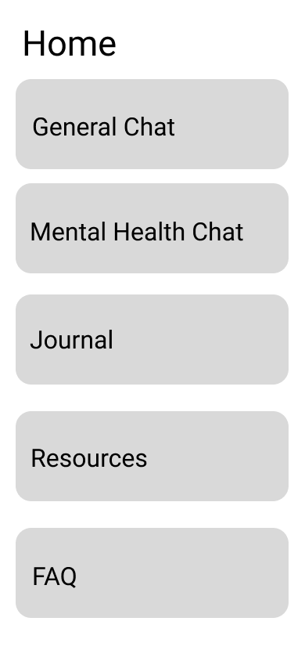
  - 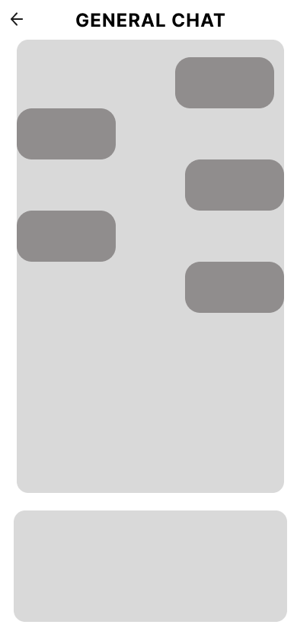
  - 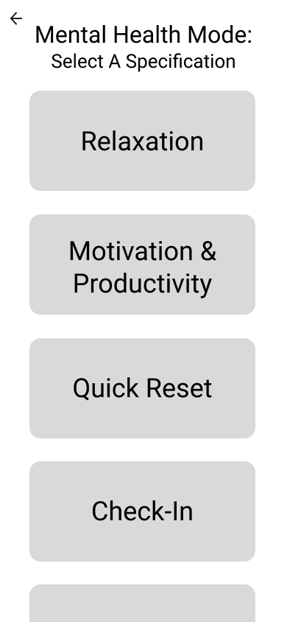
  - 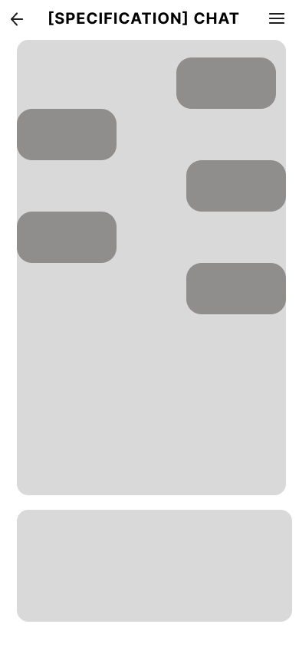
  - 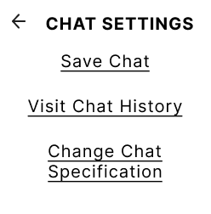
  - 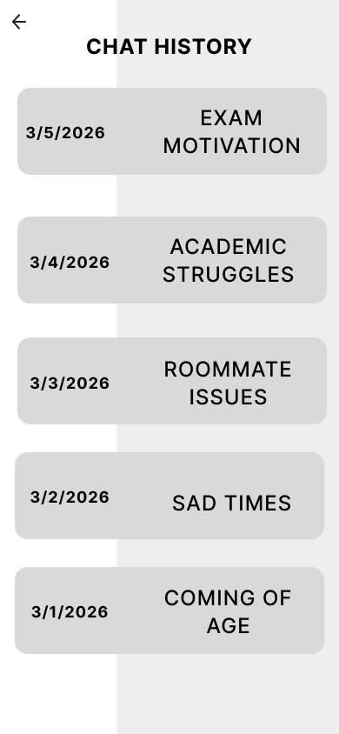
  - 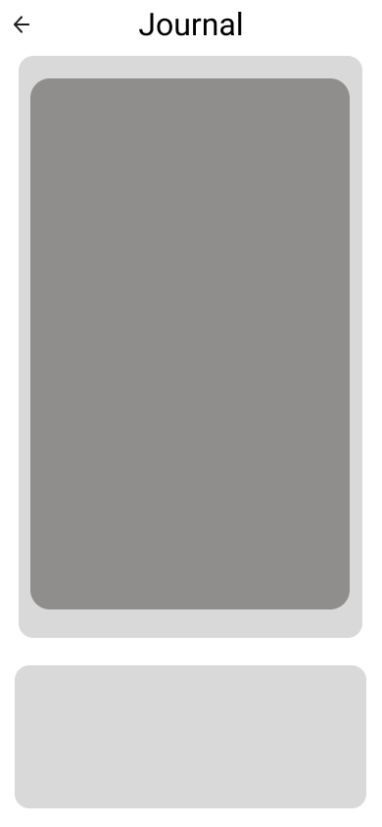
  - 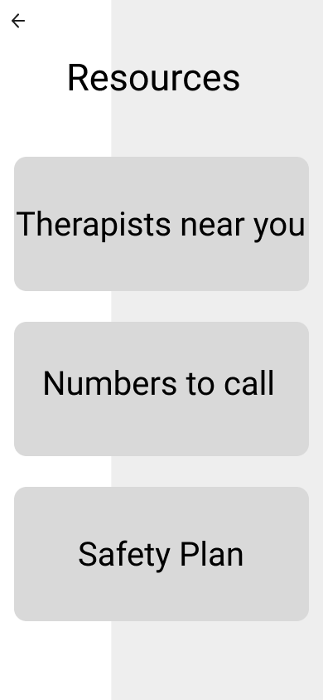

additional content

Screen 1: "Familiar chat UI reduces onboarding friction. Support Mode icon is non-intrusive — user initiates, no forced activation."

Screen 2: "Three-tier response architecture from design spec. Letting users name their need reduces cognitive mismatch and sets appropriate AI response depth. Avoids one-size-fits-all validation.”

Screen 3: "Non-intrusive detection banner — avoids forcing mode on user, preserving autonomy (SDT: autonomy support). User stays in control."

Screen 4: (2 notes) "AI asks an open question rather than immediately offering solutions — models motivational interviewing. Avoids premature problem-solving."

"Persistent resource link ensures users always have a path to human help — builds trust through behavior, not disclaimers (per design principle)."

Screen 5: "Warm handoff screen — AI explicitly acknowledges its limits and points to real humans. Reflects users' desire for AI that 'knows what it doesn't know'. Resource list is location-aware in final design."

Screen 6: "Conversation memory is opt-in, not default — directly addresses privacy concern raised across all 6 interviews. Self-contained interaction design avoids habit-loop or dependency feelings."

Put images here

Design annotations here

Screen-by-Screen Content

Screen 1 – Chat Home
This is the existing LLM chat interface (think ChatGPT mobile).
Elements to add:
- Top bar: App name (e.g., "ChatGPT") + hamburger menu icon (3 lines) on the left
- Large text input bar at bottom: placeholder text "Message ChatGPT"
- 2–3 previous chat bubbles in the feed (gray rounded rectangles — use rectangle tool, R, with corner radius ~12)
- A small shield or heart icon in the top-right corner labeled "Support Mode" — this is your new feature entry point
Annotation box (use a text box with a dashed border rectangle behind it):
"Familiar chat UI reduces onboarding friction. Support Mode icon is non-intrusive — user initiates, no forced activation."

Screen 2 – MH Mode Prompt (Trigger Detection)
The user has typed something like "I've been really overwhelmed lately" and the AI detects a mental health context.
Elements:
- Replicate the chat feed from Screen 1
- Show one user bubble: "I've been really overwhelmed lately."
- Below it, a soft banner (rounded rectangle, light gray, ~60px tall) that reads:
"It sounds like you might want some support. Would you like to switch to Support Mode?"
- Two small buttons inside the banner: "Yes, turn it on" and "No thanks"
Annotation:
"Non-intrusive detection banner — avoids forcing mode on user, preserving autonomy (SDT: autonomy support). User stays in control."

Screen 3 – Mode Selection
User tapped "Yes." They now see a simple mode picker.
Elements:
- Modal sheet that slides up from the bottom (~60% of screen height; use a large rectangle with a rounded top and white fill)
- Header text: "What kind of support do you need right now?"
- 3 large, tappable option tiles (rounded rectangles, ~70px tall each):
  - "I need to vent / talk it through"
  - "Give me something to try (breathing, grounding)"
  - "Help me find professional resources"
- Small text below: "You can switch anytime."
Annotation:
"Three-tier response architecture from design spec. Letting users name their need reduces cognitive mismatch and sets appropriate AI response depth. Avoids one-size-fits-all validation."

Screen 4 – AI Conversation (Support Mode Active)
The core interaction screen. User picked "I need to vent."
Elements:
- Top bar now shows a small label: "Support Mode ON" with an X to exit
- Chat feed showing a short exchange:
  - AI bubble: "I'm here. What's been going on?"
  - User bubble: "I have three deadlines and I haven't slept."
  - AI bubble: "That sounds genuinely exhausting. Do you want to talk through what's feeling most urgent, or just get it all out first?"
- Text input bar at bottom as usual
- A small "Find a counselor near me" link pinned just above the text bar (small, unobtrusive)
Annotation (2 notes):
"AI asks an open question rather than immediately offering solutions — models motivational interviewing. Avoids premature problem-solving."
"Persistent resource link ensures users always have a path to human help — builds trust through behavior, not disclaimers (per design principle)."

Screen 5 – Resource / Redirect
Triggered either by user request or if the AI detects escalating distress keywords.
Elements:
- Full-screen card (white rectangle covering most of the frame)
- Header: "It sounds like you might need more support than I can offer."
- 3 resource tiles (rounded rectangles with an icon placeholder on the left):
  - "Penn State Counseling Services – (814) 863-0395"
  - "Crisis Text Line – Text HOME to 741741"
  - "Find a therapist near you →"
- Button at bottom: "Back to chat"
- Small text: "This doesn't end our conversation — I'm still here."
Annotation:
"Warm handoff screen — AI explicitly acknowledges its limits and points to real humans. Reflects users' desire for AI that 'knows what it doesn't know'. Resource list is location-aware in final design."

Screen 6 – End / Wrap-up
User is wrapping up the conversation.
Elements:
- Chat feed showing the tail end of a conversation
- AI bubble: "We've covered a lot. Before you go — is there one small thing you can do for yourself in the next hour?"
- User bubble: "Maybe just take a walk."
- AI bubble: "That sounds like a great idea. Take care of yourself."
- Below the last bubble: a small, subtle card: "Support Mode ended. Your conversation is not saved unless you choose to." [Save] [Don't save]
Annotation:
"Conversation memory is opt-in, not default — directly addresses privacy concern raised across all 6 interviews. Self-contained interaction design avoids habit-loop or dependency feelings."

Making It Clickable (Prototype Mode)
- Click the Prototype tab in the right panel
- Hover over a button or element on Screen 1 (the Support Mode icon) → drag the blue connector arrow that appears to Frame 2
- Set interaction: On Click → Navigate to → [target frame] → Instant or Slide In
- Connect all screens in order:
  - Screen 1 Support Mode icon → Screen 2
  - Screen 2 "Yes, turn it on" → Screen 3
  - Screen 3 "I need to vent" tile → Screen 4
  - Screen 4 counselor link → Screen 5
  - Screen 5 "Back to chat" → Screen 4
  - Screen 4 (after final exchange) → Screen 6
- Set Screen 1 as the Starting Frame (right-click it → "Set as starting frame")
- Click "Present" (play button, top right) to demo the full flow

💻 usability testing synthesis

Usability Testing Synthesis
Group 6: Grace Liou, Zack Ranjan, Simone Orange, Amanda Keller, Damilola Ogundele

Project & Context - Amanda
College students today face mental health issues such as stress and anxiety, but barriers like cost and limited access to professional help make it difficult to find support.

The main user flow covers selecting a user’s preferred mental health mode. From there, users can engage with that mode and access additional features such as journaling, looking at resources, or completing a mental health check-in.

The current screens include a home menu that presents different actions the user can take when accessing the app, including the choice of different “mental health modes,” a journaling feature, and viewing additional resources the user can access.

Figma Link

Test Findings - Zack & Dami
Test 1: Izzy – "Complete the mental health chat flow."
Izzy’s session revealed significant issues with cognitive clarity around feature availability and navigation guidance. She expressed confusion about what functions were accessible within each mode, particularly regarding how to import journal entries and which existing prompts or features were available per mode. More fundamentally, Izzy lacked clarity on the purpose and scope of each Support Mode option before selecting one, which directly impacted the ability to complete the intended task flow.

Rather than following the intended linear flow to complete the chat task, Izzy ended up exploring the entire app broadly. This suggests insufficient directional affordances within the interface. When discussing the Relaxation mode, Izzy noted that meditation or mindfulness content would be an expected feature within this option, indicating a mismatch between current capabilities and user expectations. Izzy also emphasized that the resources tab should be prioritized and made more visually prominent within the interface, reflecting a desire for clear pathways to real support.

The confusion likely stemmed from insufficient in-screen context. When mode labels are not accompanied by brief descriptions or example prompts, users do not know what they are selecting and resort to exploration to figure it out. The free-roaming behavior suggests the prototype lacked enough directional affordances—such as a clear "start here" cue or onboarding hint—to anchor Izzy to the intended task. The feedback about the resources tab reflects patterns found in earlier interviews: users want pathways to real help to be immediately visible, not buried in the interface.

Test 2: Aiden – "Explore the app comprehensively."
Aiden's session was notably clean in terms of navigation errors, completing the comprehensive exploration without taking a wrong path or becoming stuck. However, a key semantic issue emerged with the Quick Reset feature. The label "Quick Reset" was interpreted as a system-level function rather than a mental health intervention. This mismatch between the user's mental model and the intended purpose reveals a critical labeling problem that likely stems from the technical connotations associated with "reset" terminology in digital products.

Aiden's exploration surfaced constructive feedback about feature development. Initiative prompts or starter questions displayed within each mental health mode would be a valuable next step, giving users a clearer sense of how to engage once they have selected a mode. Additionally, the journal feature's purpose and functions could be further developed; Aiden suggested that a dedicated cover or landing page and more defined journaling capabilities would strengthen this tool and make it feel less like a placeholder.

Aiden's clean navigation experience suggests the overall structure and layout are intuitive enough for broad exploration. However, the semantic issue with "Quick Reset" is significant: without visual or textual context making it clear that this is a calming or grounding feature, users default to the wrong mental model. The journal feedback aligns with a general desire for features to feel more purposeful and fleshed out rather than placeholder-like—an expectation that is reasonable at this prototype fidelity but worth prioritizing in the next iteration.

Test 3: Ryan – “Navigate to the chat settings.”
In this test finding there was confusion during the user testing with Ryan because the features and instructions were not clearly explained or easy to navigate. The participant was unsure about things like importing journal entries and understanding the different modes, which showed a lack of clarity in the design.

In this test finding, the confusion led to errors in how the user completed the task. Instead of focusing on the mental health chat flow, the participant ended up exploring the entire app, which means the flow was not guided enough.

In this test finding, the user’s comments helped highlight what was missing. They expected more focus on relaxation features like meditation and suggested that the resources tab should be more prominent.

Reflection & Cross-Test Synthesis - Simone
Top 3 usability problems (ranked by priority to fix).
- Unclear/confusing flow design and functions, mention of adding a menu to each page to help navigation
- Text readability with certain phone sizes, fixing responsive web design
- “Quick reset” in “mental health mode” page interpreted as a system reset feature instead of a mental health aid, needs clarification

Severity & scope (who it impacts; frequency).
- Impacts all users; it should be easily usable for everyone. Confusion shouldn’t be present, and it should be usable for people who know how to use basic application functions.
- The frequency of the problems was quite frequent. It seemed each test showed there was an issue with navigating to a certain page, just because it seemed confusing or unclear how the flow would work. Even if it was their first time going through it, it should be a bit clearer.

Root-cause hypotheses (e.g., label ambiguity, affordance, navigation depth, missing status, misaligned mental model)
- The flow and formatting were confusing and could have been formatted better. It should be developed in a way that has a clear flow and allows you to easily get back to the main home menu. The main problem that led to issues for users was confusion with formatting and the paths that were designed. Certain functions need to be more clearly labeled, as well as being able to easily navigate back to the menu without having to click through multiple times.

Successes to keep (what worked and why)
- The hamburger menu was something testers thought was helpful, but it should have more options and should be available on every page. It makes the navigation process easier, so it just needs to be adjusted a bit more. A decent amount of the formatting was clearly labeled, but some parts would lead to confusion, which needs to be looked over.

Design Refinements, First Iteration - Grace
To address the usability problems mentioned in the reflection and cross-test synthesis, we plan on evolving our low-fidelity wireframes to include the following:
- Integrate the existing ChatGPT UI to our prototype. This will reinforce the feeling of familiarity, making navigation more intuitive. Currently, our wireframes are solely feature-focused, so we have a clear idea of how we want each feature to look like and function. The wireframes below address the issues of unclear user flow and readability by adding a global sidebar menu for the user to use to navigate throughout each page and integrating that existing UI.
  - 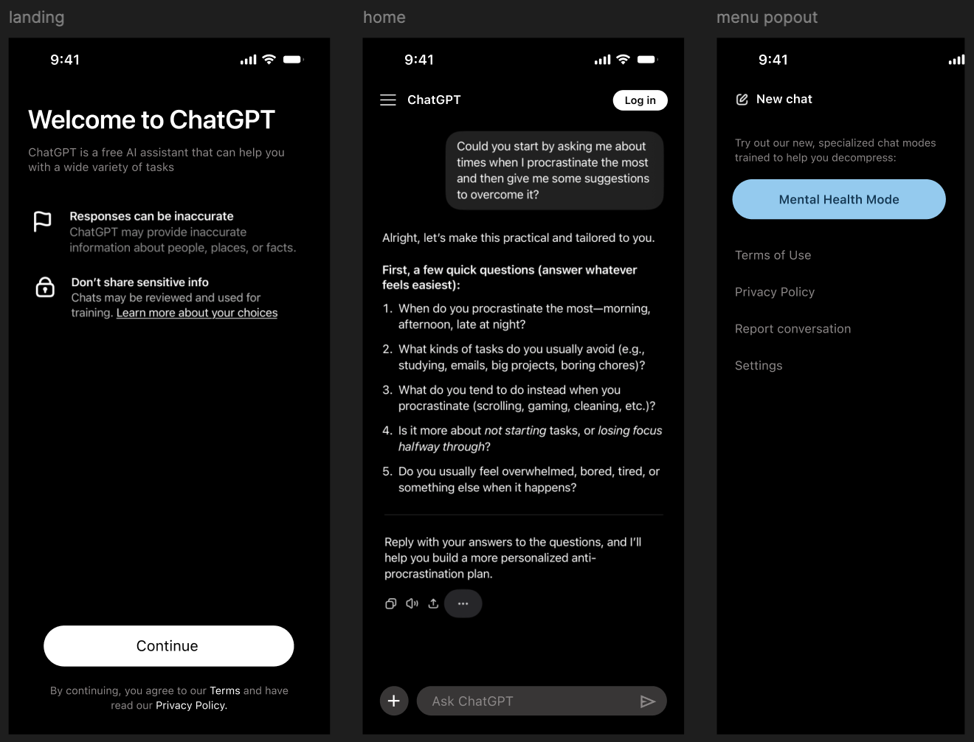
- This wireframe outlines how the landing page for our ‘Mental Health Mode’ would look, replacing the original “Quick Reset” button with a “Decompress” button to be more clear about chat mode purposes.
  - 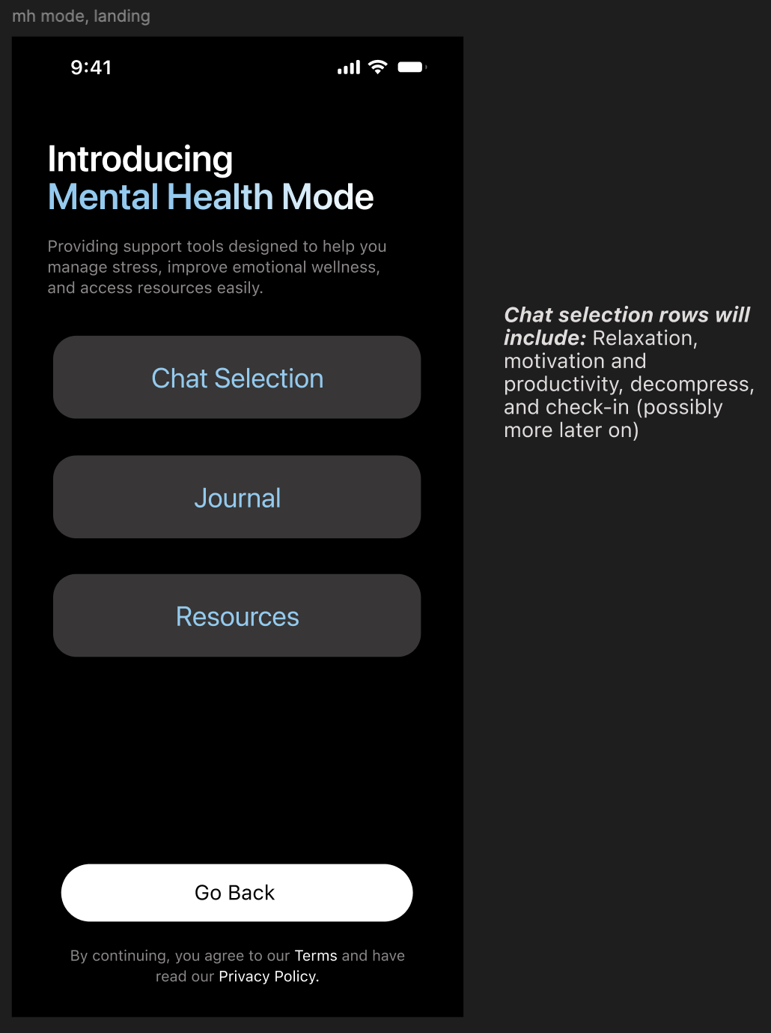

Evidence Appendix
Appendix: A
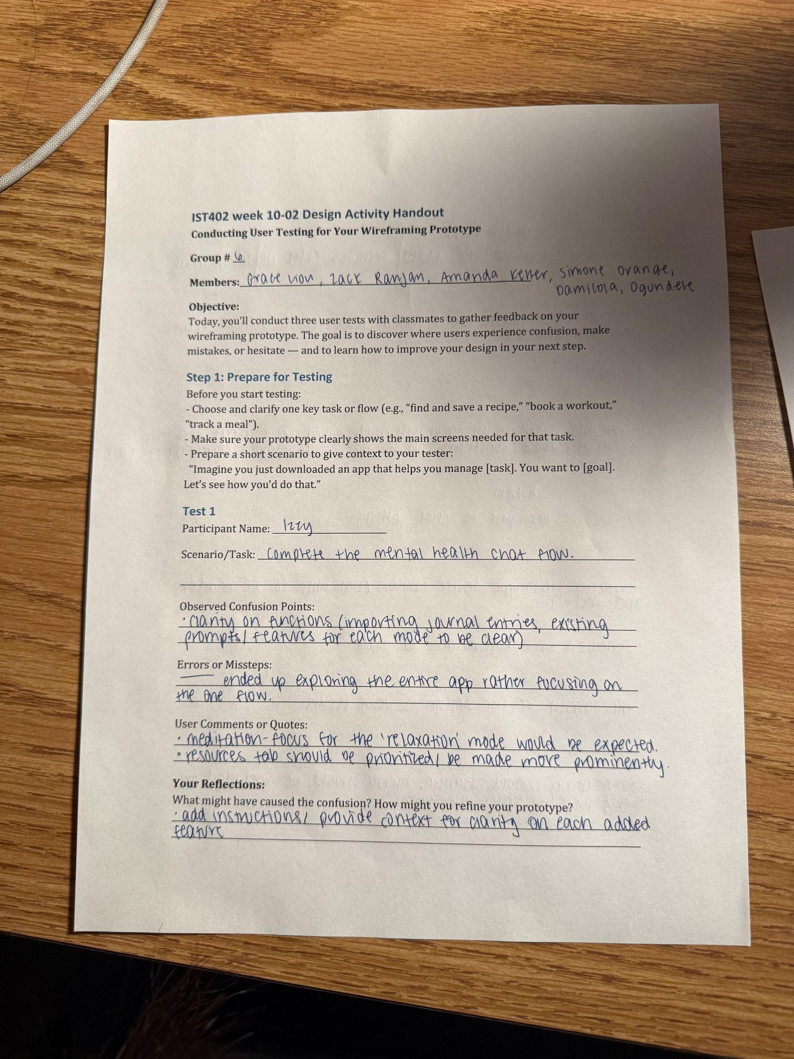

Appendix: B/C
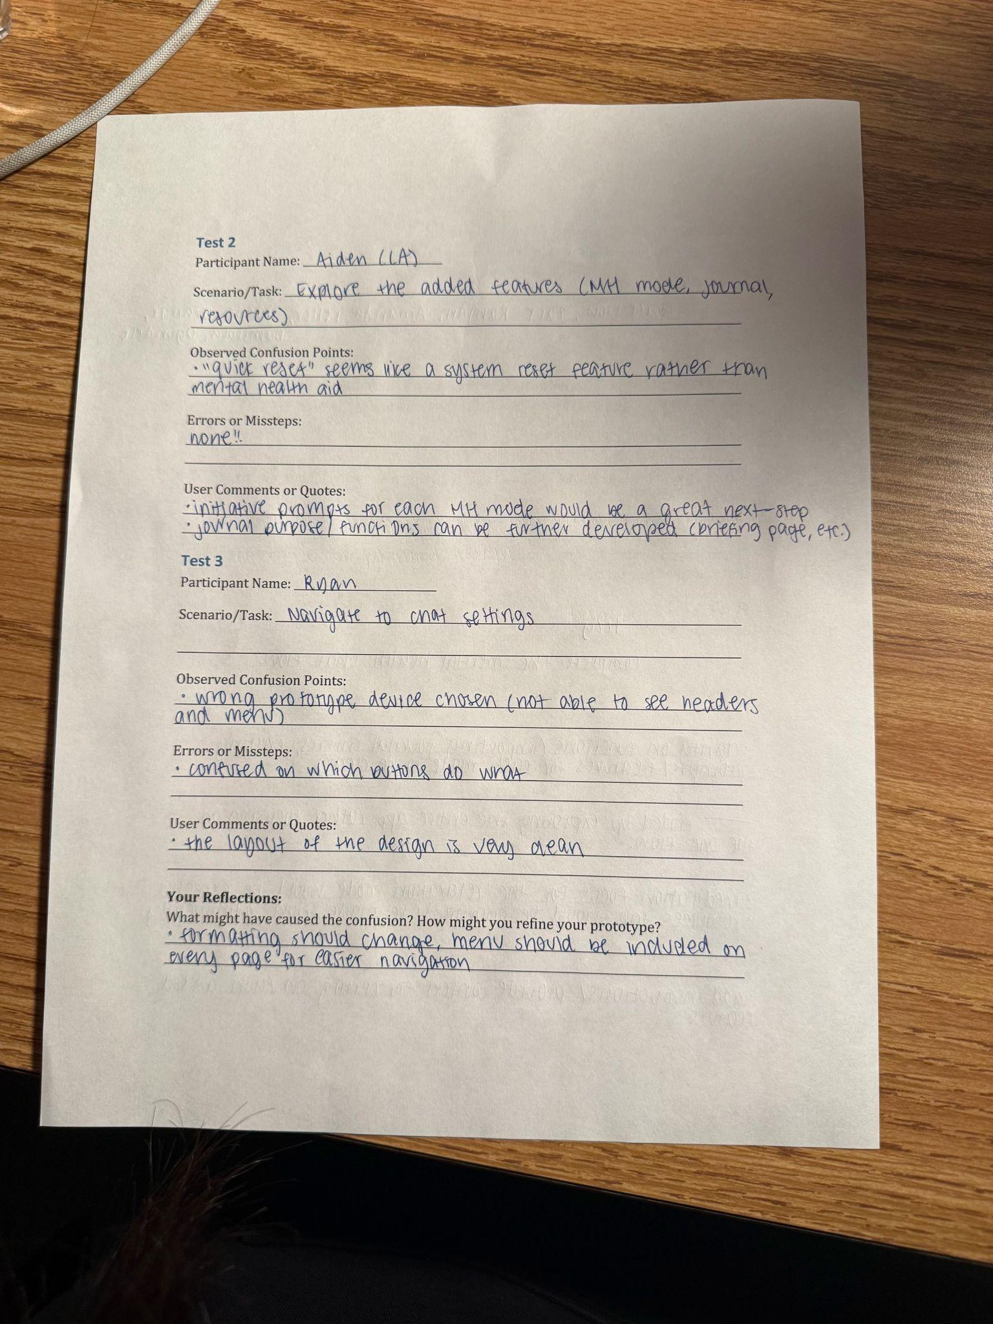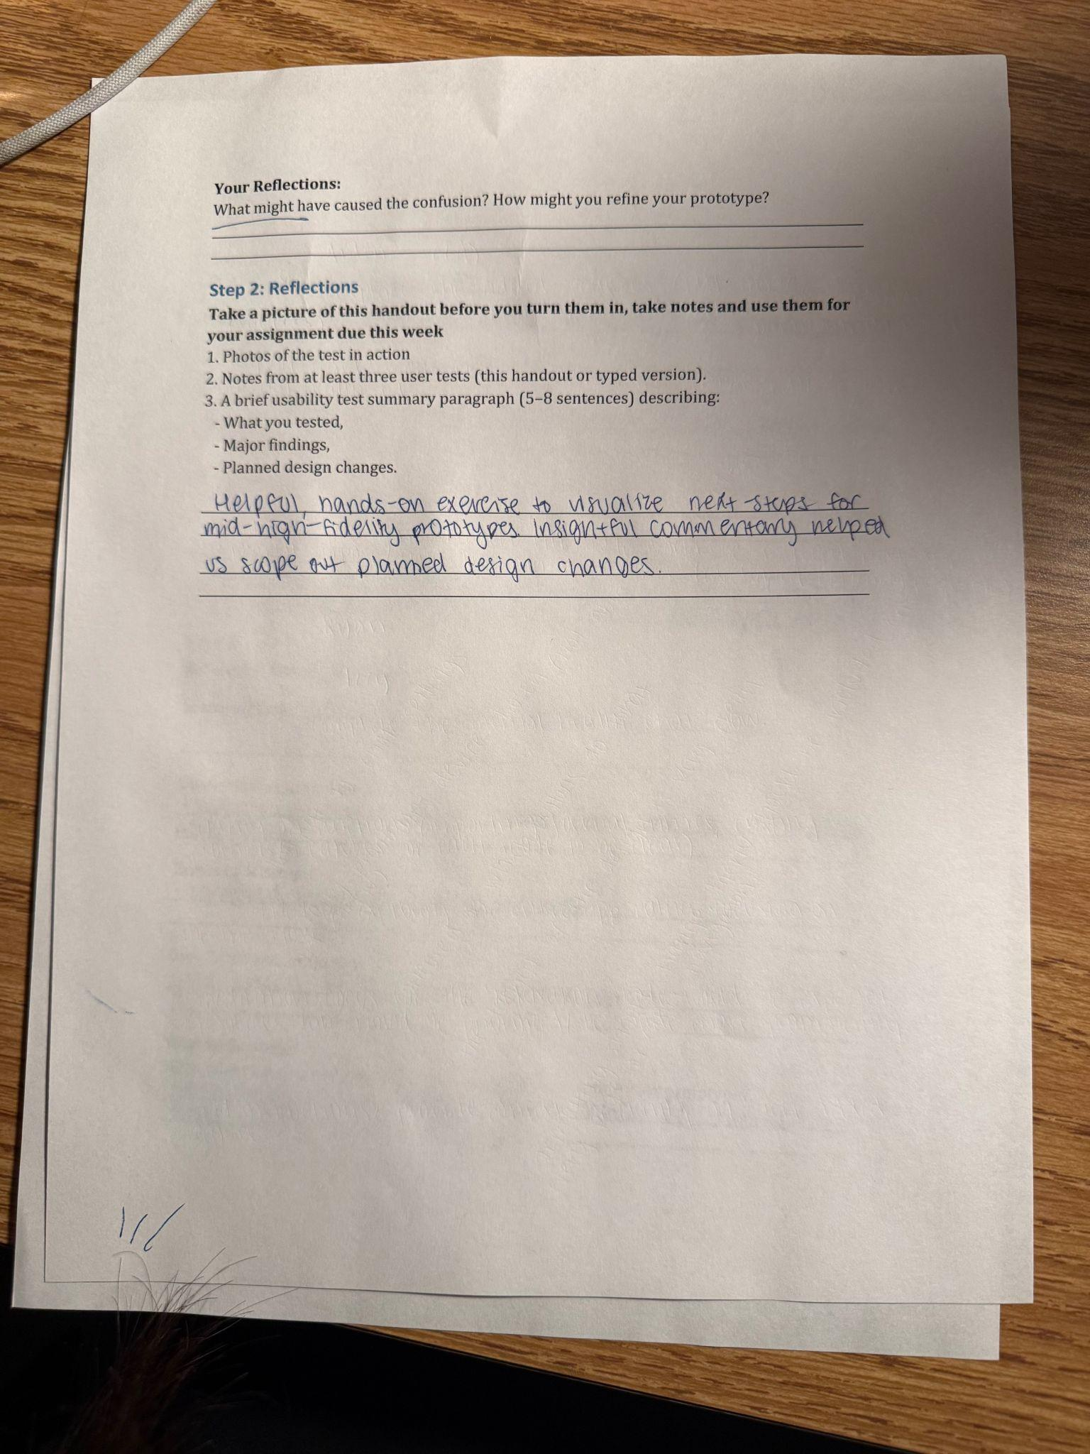

Figure 1: Shows the layout of the interface but does not include the hamburger slider the users was searching for 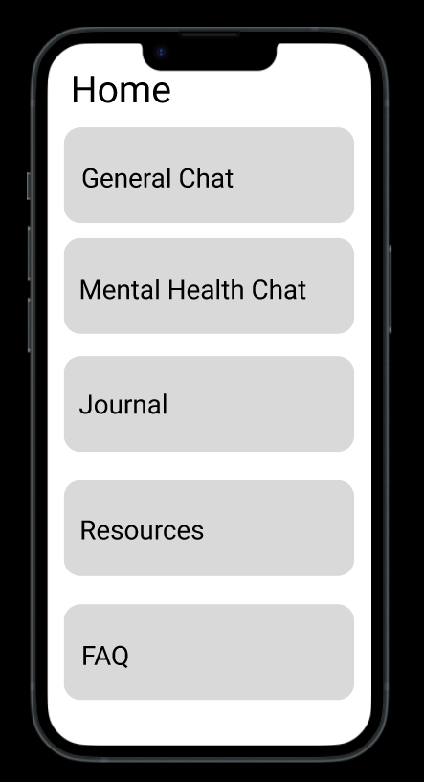

Figure 2: This image shows how the layout of the phone blocks the features for the user as well as covers the mode used causing confusion 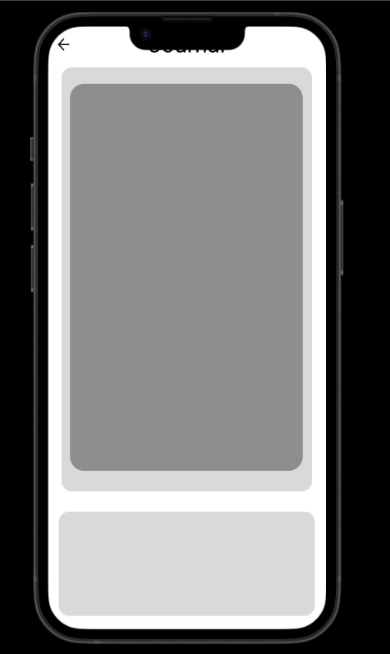
Figure 3: This image shows the formatting issue with the interface and how the layout and formatting obstructs the user views making it less interactive. 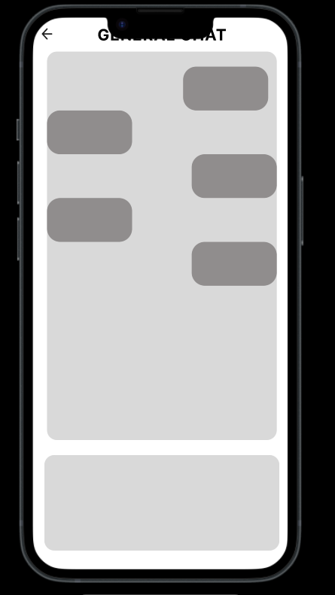
Figure 4: This image shows how the hamburger menu is difficult for the user to find due to it not being on every page as well as not including a home page to make navigation easier for the user. 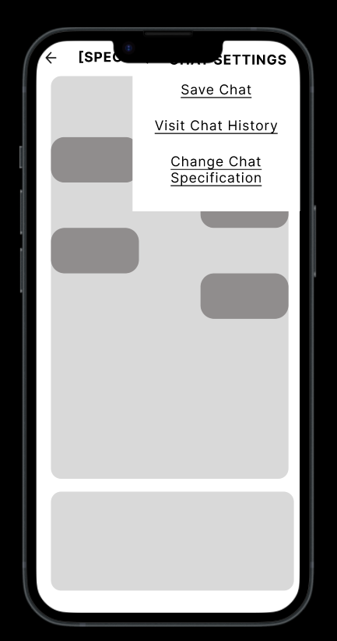
Figure 5: This image shows the formatting issue with the interface and how the layout and formatting obstructs the user views making it less interactive.
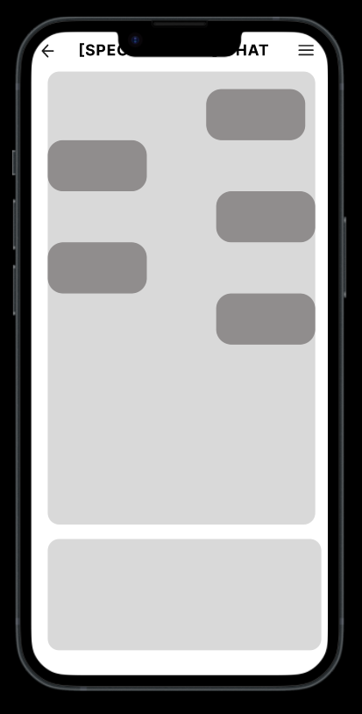

💻 Usability Test Synthesis pt 2

Usability Testing Synthesis II
Group 6: Grace Liou, Zack Ranjan, Simone Orange, Amanda Keller, Damilola Ogundele

Feature Set for Final Design prototype
- Entering Mental Health Mode button: Brings users to our system integration, mental health mode, which includes specialized chats (relaxation, motivation & productivity, decompression, etc.), specialized chat closure, settings and history, user journal, and resources.
  - Success Criterion: It should be easily accessible for users (through our added hamburger menu tab) so they don’t get confused about where to find the button. Our tests should run smoothly when tasking users with finding a certain mental health chat mode.
- Specialized chats: Specially trained LLM chats focused on specific issues including relaxation, motivation and productivity, decompression, quick check-in, etc.
  - Success Criterion: The different chat labels should make sense for users so they know what each mental health chat mode will do. During testing, there shouldn’t be any confusion on which chat button to pick depending on the needs of the user.
- Chat closure/wrap-up: Allows the user to either save the chat to their history, get a comprehensive summary of the discussion, or both via a final provided prompt.
  - Success Criterion: The buttons for each of these should be clearly labeled to the point where the testing user can easily know which one to pick. The amount of hesitation for picking should be minimal, and it should be in a place where it can be easily found.
- Chat history: Allows users to access previous chats.
  - Success Criterion: The path to chat history should be clearly shown for our users testing the system. It should be very user friendly so that they can easily access and see the history. There should be little to no hesitation during the testing process.
- Journal: A personal journal that allows each user to document their thoughts without interruption or prompting; can be imported into a specialized chat for discussion with LLM.
  - Success Criterion: The importation process should be made through a user-friendly path, and there shouldn’t be any struggle when testing the process. Accessing the journal should also be very accessible and user-friendly.
- Resources: A comprehensive list of external resources for the user based on geolocation settings, or manually inputting a location to find lists of in-person resources near them; includes general safety protocols as well; currently includes: therapists near you, numbers to call, and safety plan.
  - Success Criterion: The process for inputting a location should be simple for the user, and all of the options available should be quick and easy to go through. The time taken during the testing process will be able to help us determine if it needs to be changed for a person who could be in distress and needs access to help quickly.

User Flows
- Flow A: Chat with a specialized LLM
  - (1) land on the Landing page (existing ChatGPT flow) → (2) enter the Home page (chatting with the LLM) → (3) tap on the hamburger menu to access the Menu popout → (4) click the Mental Health Mode button → (5) select the Chat Selection button → (6) pick from the specialized options (relaxation, motivation and productivity, decompress, check-in, etc.) → (7) chat with the LLM
    - The new flow added here is through adding the existing ChatGPT UI flow, so that their current users are not shocked by a total redesign of their mobile UI. It walks through the entire process from entering the app, to accessing mental health mode, to choosing a specialized chat.
  - Flow summary: A user who is already familiar with ChatGPT wants to access a mental health-specific conversation during a stressful moment, and navigates from the standard chat interface into Support Mode to select a specialized chat type that fits what they need right now.
  - User Interaction: When the user opens the app, they land on the familiar ChatGPT landing screen and tap into the main Home page where standard chat is available. Rather than typing into the general chat, they tap the hamburger icon in the top-left corner. They tap the “Mental Health Mode” button. This takes them to the Chat Selection screen, where they are presented with a set of specialized chat options: Relaxation, Motivation & Productivity, Check-In and others. The user reads the brief label for each and taps the one that best matches their current state, for example: “Decompress.” The app transitions into the specialized chat environment, where the LLM opens with a context-appropriate prompt tailored to decompression rather than a generic greeting. The user types their first message and the conversation begins. Because the entry point is embedded within the existing ChatGPT UI rather than a separate app, the user experiences the transition as a mode shift rather than a platform switch, reducing friction and keeping the interaction feeling familiar.
- Flow B: Journal entry access and exporting
  - (1) land on the Landing page → (2) enter the Home page → tap on the hamburger menu to access the Menu popout → (3) click the Mental Health Mode button → (4) select the Journal button → (5) pick from multiple options (new journal entry, exporting a past journal entry for personal use, importing an external journal entry into the app, etc.) → (6) engaging with the journal entry (creating journal entry, importing journal entry, exporting journey entry, editing existing journal entry, etc.) → (7) Choosing whether to save or not save the journal entry.
    - The new flow added here creates a comprehensive experience for the journaling feature of our system integration. Instead of just adding a journal with no additional purpose other than to write down thoughts, we’ve made it so the user can export/import their saved journal entries into a specialized chat.
  - Flow summary: A user wants to revisit a past journal entry and either export it for personal use or import it into a specialized chat so they can process its contents with the LLM in a focused conversation.
  - User interaction: When the user wants to enter a new journal entry, they will find themselves on the landing page after opening the app, then leading them to the home page. Where from there the user will utilise the hamburger menu and access the menu popout. Through there the user will find the Mental Health Mode and select the Journal button. With the journaling feature the user is able to write a new journal entry, export a past journal entry for personal use, import an external journal entry into the app, etc. From there the user is able to interact with the journal entry how they see fit with many features to choose from. Afterwards then finally choosing at the end if the user would like to save their journal or not.

Evidence appendix
Appendix A: Miro User Flow Board
https://miro.com/app/board/uXjVGf6OBE8=/?share_link_id=739118044235
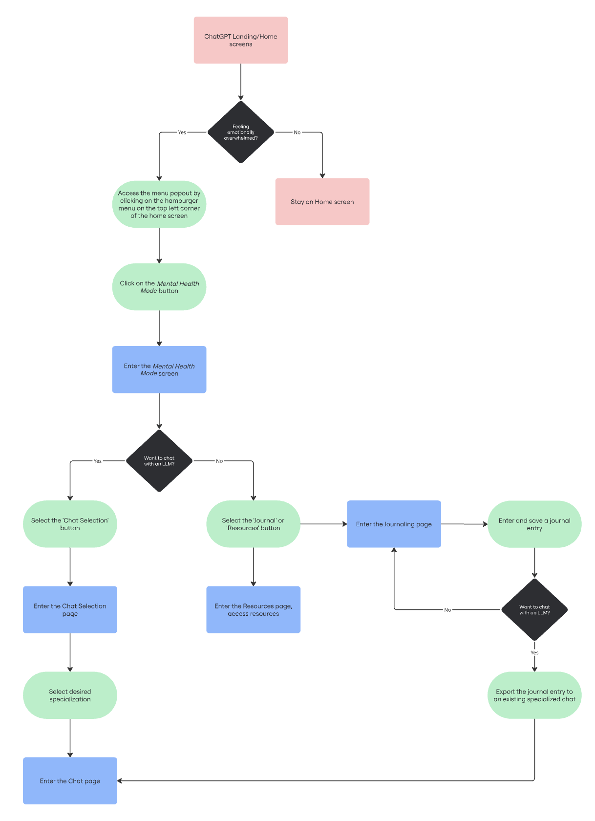

💻 Hi-Fi Prototype

Hi-Fi Prototype
Group 6: Grace Liou, Zack Ranjan, Simone Orange, Amanda Keller, Damilola Ogundele

Figma Link

Project Overview
Young adults struggle with regulating their mental health when there’s a lot going on in their lives, because they’re in a stage of life that comes with many milestones, which is due to the many changes that occur during this time (shifting from childhood to adulthood).
The target age group for this focus would be people of all ages, however specifically aiming towards young adults and adults (18-35). The context in mental health would be anyone that is battling or struggling with anxiety, depression, stress, etc. This includes people of all job types and backgrounds who are seeking therapeutic guidance and may not have the financial resources for professional help.

User Flows
- Flow A
  - Goal statement: A user wants to access a mental-health specific conversation and navigates from the standard chat interface into Support Mode to select a specialized chat.
  - 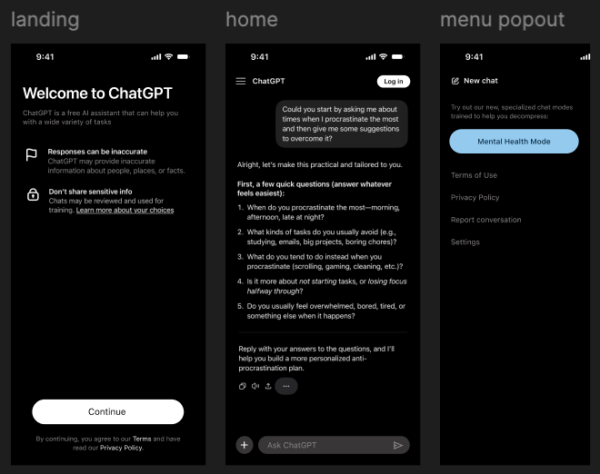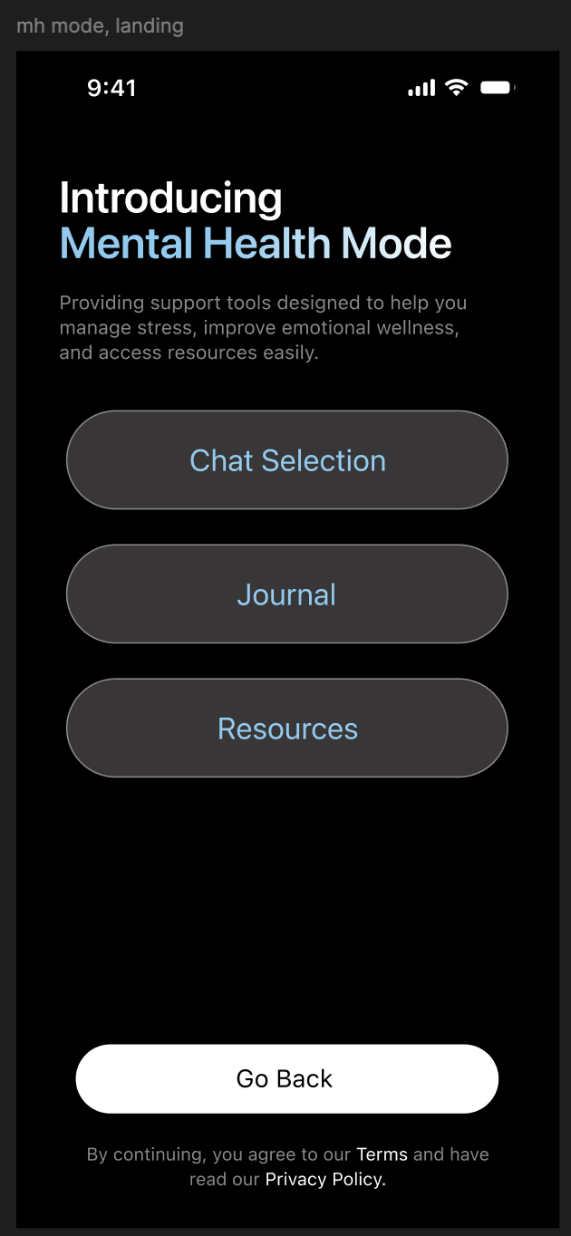
  - 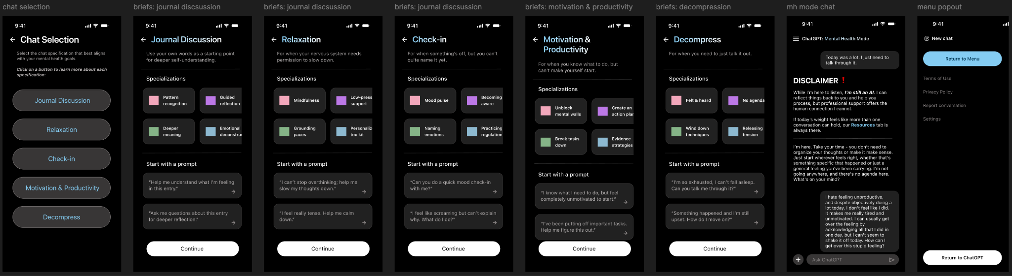
  - (1) land on the Landing page (existing ChatGPT flow) → (2) tap the white “continue” button to enter the Home page (chatting with the LLM) → (3) tap on the hamburger menu to access the Menu popout → (4) tap the blue Mental Health Mode button → (5) tap the Chat Selection button → (6) pick from the specialized options (relaxation, motivation and productivity, decompress, check-in) and tap a button option → (7) use the keyboard to type and chat with the LLM
- Flow B
  - Goal statement: A user revisits a journal entry to export/import into a specialized chat or save.
  - 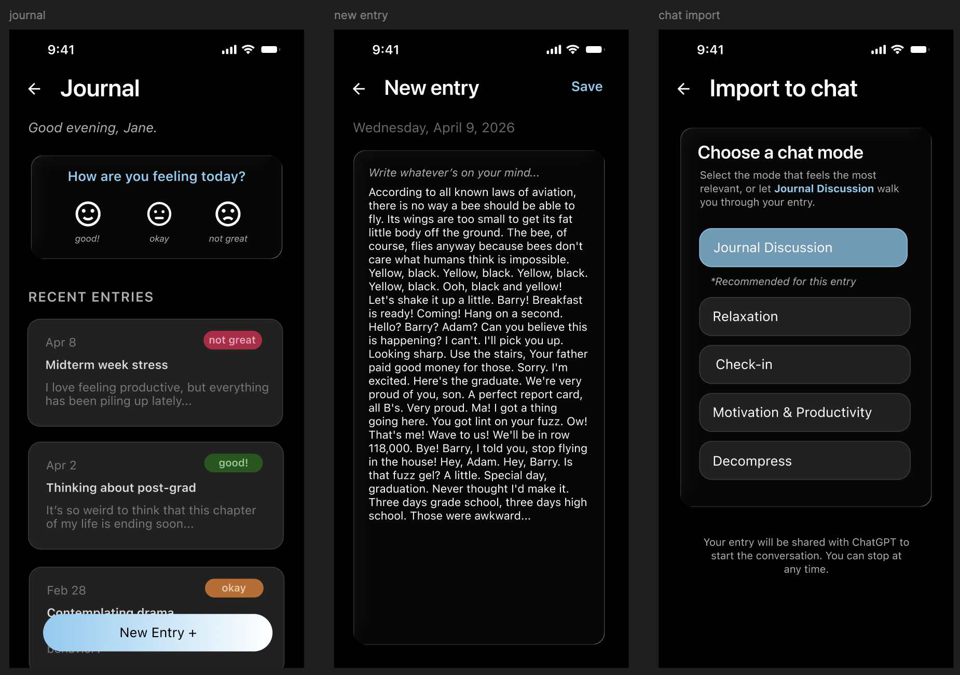
  - (1) Landing Home → (2) Home → (3) Menu popout → (4) Mental Health mode chat → (5) Chat Selection → (6) Briefs: Journal Discussion → (7) Resources
  - (1) land on the Landing page → (2) enter the Home page → tap on the hamburger menu to access the Menu popout → (3) click the Mental Health Mode button → (4) select the Journal button → (5) pick from multiple options (new journal entry, exporting a past journal entry for personal use, importing an external journal entry into the app, etc.) → (6) engaging with the journal entry (creating journal entry, importing journal entry, exporting journey entry, editing existing journal entry, etc.) → (7) Choosing whether to save or not save the journal entry.

Iteration Summary + Testing
Our original design was more simplistic than our current design. When starting off, we made the design look more like an app than an add-on to ChatGPT. We changed the font to match the format of ChatGPT and put the “dark mode” setting on to match the dark mode settings iPhone users typically prefer. This was put in place to match the format of ChatGPT and make the layout “blend in” to ChatGPT’s layout. Along with that, we added text on the bottom of the landing page as a discretion for the user to see, which is common among large language models. This serves as a reminder that AI can make mistakes and the user is agreeing to the terms and conditions that come with using this platform. Another change we made to the design is providing the user with example starter prompts to give them an idea of what they can ask for help with. This way, the user understands how the platform can be used and common prompts that start off the conversation with AI.

Design Changes + Rationale
- Integrated UI – We hadn’t implemented or followed ChatGPT’s actual UI up until this point, so the primary change made was leveraging their existing UI/UX to spark inspiration for the flows of our current screens.
  - Rationale: The low-fidelity wireframes left a lot of open-ended questions for the user – what kinds of menus or buttons would the user be interacting with? Would they be pressing words? Where does this next step happen? Implementing the actual UI helped to clear up those holes.
- Glassmorphism buttons – To follow current UI trends in tech, we decided to go with some glass integration throughout our screens.
  - Rationale: People appreciate familiarity, bringing a technical side to something that’s trying to balance both humanness and AI aspects.

Use of AI
The mobile app of ChatGPT was used as a reference to their current user interface and experience, and nothing more. The primary inspiration for design changes came from user interviews and feedback, as well as Claude for integration inspiration. Prompts utilized included, “I feel like this screen is too wordy. I think have buttons/icons will bring the page to life while still being informative. Help me figure out a revised layout for this screen.”

💻 Preparing & Conducting Final User Tests
In-Class Design Activity: Final User Testing Notes Template
Group 6: Grace Liou, Zack Ranjan, Simone Orange, Amanda Keller, Damilola Ogundele
Date: 4/14/2026

Prototype Link: https://www.figma.com/proto/4rpNbXUYRyBXK9ydSEcSSv/ist-402--MH-Support-Wireframe?node-id=100-71&t=iJk3shAszi49bPAV-1

Test 1
Participant Name: Izzy
Task/Scenario Tested: Chat selection
Notes:
- Starting from the primary existing LLM screen
- Accessed mental health mode easily, might need additional prompting to know the feature is happening
- Wants the buttons highlighted in the chat briefing screen (maybe additional context from the focus boxes/prompts should go straight through to the LLM chat)
- Likes the disclaimer and how the original response doesn’t require that much additional context from the user
- Looked through the resources as well
- Found the flows to be really organized
- On resources tab, acknowledged the red box for crisis to be helpful
- Really liked the recent entries feature of the journal
  - Suggests bullet journaling features
  - “Organized logging system”

Test 2
Participant Name: Zach
Task/Scenario Tested: Journaling- import chat settings page
Notes:
- Very quickly went through the pages and was able to find everything
- He said that there were no issues going through the task flow
- He enjoyed the setup of the mental health mode page
- Was able to assume which page to go to for the journal entry based on the labels and where to go for the new entry page.
- Overall, very straightforward, it was really easy for him to find everything, and he didn’t have any complaints about confusion or misleading pages.
- Noticed that maybe the save button should not navigate to import to chat

Test 3
Participant Name: Shreya
Task/Scenario Tested: Navigate to the resources tab and look through the provided features
Notes:
- Found mental health mode from the menu very easily
- Navigated to chat selection first, probably didn’t read through all the tabs provided in the menu page of mental health mode
- Did everything in order of placement on the screen (top to bottom) rather than taking autonomy to actually look through what was provided
- Be able to have the journal page scrollable, and also add the ability to look at summaries of each journal entry when you tap on it

Quick Wrap-Up
- Users wanted the journal page to be scrollable and minor buttons to be clickable/an actual function/feature
- Minor edits need to be added with certain features but overall the process of going through the tasks was very smooth for each of the users
- Next steps:
  - Make everything interactive (scrollability, no empty button features)
  - Complete the self-guided tools screen
  - Make the save journal functionality a popout rather than import to chat, and move import to chat into the primary journal landing page

💻 User Testing 2 Iteration Plan & Reflecting
Group 6: Grace Liou, Zack Ranjan, Simone Orange, Amanda Keller, Damilola Ogundele
Date: 4/14/2026

Prototype Link: https://www.figma.com/proto/4rpNbXUYRyBXK9ydSEcSSv/ist-402--MH-Support-Wireframe?node-id=100-71&t=iJk3shAszi49bPAV-1

A. Project Snapshot
- Project title
  - ThriveAI
- 2–3 sentence reminder of your problem, target user, and what your prototype is trying to support
  - ThriveAI is used to support youth and young adults who have difficulties with their mental health or during a stressful period in their lives. This AI powered space is accessible for users to engage in guided conversation, journaling, and personalized support without needing immediate access to professional therapy. This AI tool focuses on helping users being able to regulate their emotions, build healthy coping habits, and reflect on their experience with the structured tool.

B. What You Learned from User Testing
In a short reflection, summarize:
- What parts of your design worked well
- What suggestions, confusion, hesitation, or usability issues came up
- Any repeated patterns across users
- Any surprising or useful takeaways from testing
Aim for about 1 short paragraph (5–7 sentences).
The users found the prototype easy to navigate and found the user flows intuitive. The labels for the buttons made it easy for users to complete the task that was given. We were given minor suggestions regarding interactivity and certain page features. We noticed that users would thoroughly look through the different pages depending on what their task was. We also saw that users would get through the first few pages of their task quickly and would slow down once they were reaching the end of their task.

C. Iteration Plan
Identify the top 3 changes your group plans to make before the final presentation.
For each change, include:
- What you will revise (Be specific. This will help clarify what your group still needs to complete next week)
- Why this change matters based on testing (Explain what feedback, confusion, or usability issue led you to this revision)
- How you hope it will improve the user experience (Briefly describe the intended benefit for users)
Keep each design change brief, around 2–4 sentences, and you may use bullet points to organize this section clearly.
- Scrollable journal page and tappable/clickable example entries
  - The current journal page has examples of prompts with only the titles but the page isn’t very interactive outside of showing the screen and other pages to go to. This revision will allow the user to scroll down to see the different examples just as they would with a real app. The click/tap ability that will be added can provide users with the ability to look at short summaries of their entries.
- Ensure everything is interactive
  - Implementing smooth transitions between screens and functioning buttons across pages. This will go along with adding the ability to scroll for the journal page, so any other pages that don’t have full interactivity will have it fully implemented. This will just be one of the wrap-up steps of our project, since a majority of the app is interactive. It will ensure there are no unusable buttons or features for future users and can prevent any confusion.
- Change the save journal function
  - The goal is to change the “save” button that we currently have to be a popout, and we will change the current import to chat popout to be on the main journal page. It seems that there was some confusion with clicking that button and it bringing up a different menu. It will hopefully remove any confusion that was present, as well as make the two functions more clearly separated.

💻 Final Design Prototype

Final Prototype Short Write-Up
Clear summary of what changed
Strong explanation of why those changes were made
Thoughtful reflection on future improvements/features

Prototype Link: https://www.figma.com/proto/4rpNbXUYRyBXK9ydSEcSSv/ist-402--MH-Support-Wireframe?node-id=100-71&t=iJk3shAszi49bPAV-1

A. Summary of Changes Made
Briefly describe the small changes or fixes your group made after the final presentation.
Explain:
- What feedback you responded to
- What you changed in the prototype
- How those changes improved clarity, usability, or presentation quality

A lot of the feedback we received from the final presentation was very positive, so a lot of the changes made were based on the second user testing feedback, and any changes we personally identified that should be added. The prototype is overall complete, and the changes suggested after user testing were added for the final presentation.

B. Future Design Ideas
Briefly describe what additional design changes, improvements, or features you would want to add if you had more time beyond finals week.
These can include:
- features you could not fully build
- flows you would refine further
- ideas that came up from feedback but were too large to implement now

For future design features, we would make the pages scrollable for chat features. Additionally, we would add hover features so that the users can see the buttons they are putting their mouse over before clicking on it. Some other changes that could be made are to make some of the images in the categories on the “Chat Selection” page outside of “Journal Discussion” clearer. They’re different images because the categories are different, but some look blurrier than others, which could make them hard to read for users going through the prototype.

